### PROJECT REPORT

ON

### “Knowledge Representation and Insight Generation from structured dataset”

is submitted to

Intel Unnati Industrial Training 2024

**Prof. Ram Meghe Institute of Technology and Research, Badnera, Amravati.**

By

**Mr. Pranav Rajput Mr. Yash Lawankar**

**Mr. Yash Dighade**

Under the Guidance of:

### 

### Dr. R. R Karwa Intel Industry Mentor Prof A. U. Chaudhari



**Prof. Ram Meghe Institute of Technology and Research, Badnera, Amravati.**

**(An Autonomous Institute & NAAC Accredited)**

**Sant Gadge Baba Amravati University, Amravati**

**2024-2025**

**PROF. RAM MEGHE INSTITUTE OF TECHNOLOGY AND RESEARCH, BADNERA,**

**AMRAVATI.**



### CERTIFICATE

This is to certify that

**Mr. Pranav Rajput Mr. Yash Lawankar**

**Mr. Yash Dighade**

has satisfactorily completed the project work towards the **Intel Unnati Industrial Training 2024** indiscipline on the topic entitled **“Knowledge Representation and Insights Generation from structured dataset”** under my supervision. The student was trained by Intel experts.





Dr. R. R. Karwa Prof A. U. Chaudhari

**Mentor Mentor**

**ACKNOWLEDGEMENT**

The backing and direction of numerous people and organizations were essential to the project's successful conclusion. We want to sincerely thank each and every one of them. We are incredibly grateful to **Intel Corporation** for giving us the chance to work on this project as part of the Intel Unnati Industrial Training program. It is very admirable how dedicated they are to promoting innovation and technical proficiency. We want to express our sincere gratitude to the organizers and directors of the **Intel Unnati Industrial Training Program 2024** for their immense help and direction during the entire process. Their systematic methodology and training that was pertinent to the industry really influenced our comprehension and project management.

We were deeply indebted to **Prof. Ram Meghe Institute of Technology and Research, Badnera, Amravati**, for providing the platform and infrastructure necessary for this project. The institute's commitment to academic excellence and its supportive faculty have played a vital role in our learning journey. We would like to express our sincere appreciation to **Intel Point of Contact Dr. R. R. Karwa**, for their constant support, insightful feedback, and technical guidance throughout the project. Their expertise and mentorship were invaluable assets in navigating the challenges and ensuring the project's success. Our sincere gratitude goes to our faculty mentor**, Dr. R. R. Karwa and Prof A. U. Chaudhari** for their constant encouragement, constructive criticism, and unwavering support during the project development. We would also like to extend our thanks to Intel Industry Expertfor their support and contributions to this project.

We were grateful for the opportunity to have worked on this project and for the valuable learning experience it has provided.

#### Name of student(s):

** Mr. Pranav Rajput**

** Mr. Yash Lawankar**

**Mr. Yash Dighade**

**Table of Contents**

|  |  |  |  |
| --- | --- | --- | --- |
| **Sr no.** |  | **Contents** | **Page no.** |
|  |  | Abstract |  |
| **1** |  | **Introduction** |  |
|  | 1.1 | Overview | 1 |
|  | 1.2 | Motivation | 2 |
|  | 1.3 | Problem Statement | 2 |
|  | 1.4 | Research Objectives | 2 |
| **2** |  | **Literature Review** | 4 |
| **3** |  | **Dataset** | 10 |
| **4** |  | **Propose Methodology and Architecture** |  |
|  | 4.1 | Data Ingestion | 15 |
|  | 4.2 | Loading Data | 16 |
|  | 4.3 | Data Processing | 17 |
|  | 4.4 | Data Visualization | 18 |
|  | 4.5 | Clustering | 19 |
|  | 4.6 | Regression Analysis | 20 |
|  | 4.7 | Insight Generation | 22 |
|  | 4.8 | Visualization and Reporting | 23 |
|  | 4.9 | Architecture Diagram and Description | 29 |
| **5** |  | **Implementation and Results** |  |
|  | 5.1 | Implementation | 38 |
|  | 5.2 | Results and Discussion | 46 |
| **6** |  | **Conclusion and Future Scope** |  |
|  | **6.1** | **Conclusion** | 59 |
|  | **6.2** | **Future Scope** | 59 |
|  |  | **References** | 62 |
|  |  | **Team Members and Contribution** | 65 |

**List of Figures**

|  |  |  |
| --- | --- | --- |
| **Fig no.** | **Title** | **Page no.** |
| 1.1 | Knowledge Representation | 1 |
| 3.1 | Life Expectancy | 11 |
| 4.1 | Data Ingestion | 15 |
| 4.2 | Loading Data | 16 |
| 4.3 | Data Processing | 17 |
| 4.4 | Data Visualization | 18 |
| 4.5 | Clustering | 19 |
| 4.6 | Regression Analysis | 20 |
| 4.7 | Insight Generation | 22 |
| 4.8 | Visualization | 23 |

**ABSTRACT**

In today's data driven world, organizations constantly produce vast volumes of structured data. Effectively leveraging this data for informed decision making requires advanced tools capable of analyzing and extracting significant insights. This project introduces an AI powered solution aimed at processing, representing, and generating actionable insights from structured datasets. The solution is designed to convert raw data into valuable knowledge through a comprehensive framework that includes data preprocessing, visualization, pattern identification, and insights generation.

The framework will include a number of essential elements. Using Python libraries like Pandas and Scikit learn, it starts with thorough preprocessing of the data to make sure it is clean and ready for analysis. Visual tools like Matplotlib and Seaborn will be used to accomplish knowledge representation, producing understandable graphs and charts that successfully convey the organization and substance of the dataset. We'll use cutting edge machine learning methods that make use of frameworks like Scikit learn to find noteworthy patterns, such as trends and anomalies. The results will be presented in an understandable manner by employing natural language generation technologies such as GPT3 to transform these patterns into cohesive insights.

Scalability and user experience are important factors to take into account, as they guarantee that the solution can handle datasets of different sizes and complexity levels while offering an easy to use user interface. This interface will make it easy to engage with and interpret the insights because it was created utilizing web frameworks like Flask. This project seeks to create a robust platform that not only processes and analyzes data effectively, but also makes the resulting insights understandable and actionable for decision makers across varied areas through the integration of AI and data analytics.

**Keywords:** *Dataset, Knowledge, Visualization, Insights, Preprocessing, Pattern Identification*

## CHAPTER 1

**1. Introduction**

Organizations continuously produce enormous amounts of structured data in today's data-driven environment. In order to use this data for well-informed decision-making, sophisticated technologies that can analyze and extract important insights are needed. The goal of this project is to provide an AI-powered method for handling structured datasets and turning them into insights that can be put to use. The solution's goal is to turn unprocessed data into insightful knowledge by using a thorough framework that includes data preparation, visualization, pattern recognition, and insights creation.



Figure 1.1. Knowledge Representation

The importance of knowledge representation lies in its ability to convert data into a format that is easily understandable and actionable. This research explores various methodologies and frameworks for knowledge representation, particularly in the context of structured datasets. By employing advanced machine learning techniques and natural language generation tools, the project seeks to enhance the analytical capabilities of organizations, enabling them to make strategic, data-driven decisions.

### Overview

The ability to effectively represent knowledge and draw meaningful inferences from structured datasets is critical in today's data science environment. A wide range of approaches and frameworks are included in knowledge representation, all aimed at gathering, organizing, and interpreting data in a way that is useful and applicable. This process is essential in many fields, such as corporate analytics, artificial intelligence, and scientific research, where the capacity to interpret large amounts of data is necessary for strategic planning and well informed decision making. This research explores and critically evaluates a range of knowledge representation strategies to determine how well they convert structured datasets into insightful information.

### Motivation

In the digital age, data is everywhere, so it's important for organizations to use data driven decision making to keep and enhance their competitive advantage। However, the challenge goes beyond

mere accumulation of data; it extends to the successful representation and interpretation of this data in order to obtain useful insights। When it comes to unlocking the latent potential of structured datasets, robust knowledge representation techniques are essential. This allows for a deeper understanding of complex data patterns and relationships. The need to bridge the gap between raw data and significant insights drives this project. The goal is to provide organizations with sophisticated methods that improve their analytical skills and help them make strategic decisions.

### 1.3 Problem Statement

The extraction of important insights from structured datasets remains a chronic difficulty for many organizations, despite notable developments in data processing technologies. The primary cause of this issue is the inadequacy of current knowledge representation techniques to handle the complexity, volume, and dynamic of modern data environments. As a result, companies frequently run into difficulties when trying to arrange their data in a way that makes it easier to find important connections and obscure patterns. This research attempts to address this issue by creating and critically analyzing strong knowledge representation approaches that can facilitate the organizing of data and improve the production of useful insights.

* 1. **. Research Objectives**

The research objective of work are as follows:

* **Analyze Conventional Models of Life Expectancy**: Review and assess existing models and methodologies used in life expectancy studies to establish a foundational understanding.
* **Investigate Factors Influencing Life Expectancy:** Examine various demographic, health, and socioeconomic variables to understand their impact on life expectancy. This involves correlating these factors with observed life expectancy trends.
* **Design a Data Processing Module**: Develop an analytical module capable of handling large datasets, preprocessing data, and extracting relevant features that contribute to life expectancy predictions.
* **Build Predictive Models for Life Expectancy:** Create and train machine learning models to predict life expectancy based on identified determinants. These models aim to provide accurate and actionable forecasts.
* **Deploy and Test Predictive Models:** Implement the models and evaluate their performance in generating life expectancy predictions. This includes assessing the accuracy and reliability of the model outputs.

## CHAPTER 2

**2. Literature Review**

This section delves into the research work done in the field of Knowledge Representation and Insight Generation.

Shi et al. (2024) [1] proposed a novel method that leverages reinforcement learning to aid in the guided exploratory visual analysis of time series data. Their approach integrates reinforcement learning techniques to enhance user interaction with visual analytics tools, ensuring more effective data exploration and insight generation. However, a gap remains in adapting these methods for broader applicability across various domains of time series data.

Harinakshi Lydia et al. [2] (2022) explored the impact of exploratory data analysis (EDA) in identifying patterns within datasets in the service sector. Their study emphasizes the importance of EDA in uncovering hidden trends and facilitating data-driven decision-making. Despite their comprehensive analysis, further research is needed to enhance the automation and efficiency of EDA processes, especially in dynamic and large-scale datasets.

Huang et al. (2022) [3] presented a rough-set-based approach for real-time extraction of interest labels from large-scale social networks. Their method effectively identifies and categorizes user interests, contributing to improved personalization and user engagement in social platforms. However, the scalability and adaptability of this method in rapidly changing social network environments require further investigation.

Zhao et al. (2021) [4] utilized neural network algorithms to perform health evaluations and fault diagnoses on medical imaging equipment. Their research demonstrates the effectiveness of neural networks in detecting anomalies and ensuring the reliability of medical devices. Nonetheless, the integration of these algorithms into existing healthcare systems and their real-time application remains an area for further development.

Hilbert and López (2011) [5] provided an extensive review of the global technological capacity to store, communicate, and compute information. They highlight the exponential growth in data generation and the challenges it poses for data storage and processing infrastructures. Their study underscores the need for innovative data management strategies to cope with the increasing data volumes and complexity.

Sagiroglu and Sinanc (2013) [6] reviewed the landscape of big data, focusing on its characteristics, challenges, and potential applications. Their comprehensive overview addresses the technological and analytical advancements required to harness the potential of big data. However, the study calls for further research into developing robust big data frameworks that can handle diverse and large-scale datasets effectively.

Chen et al. (2009) [7] explored the transition from data to knowledge through visualization techniques. They discuss various methods to enhance the interpretability of data visualizations, making them more accessible and informative for end-users. Despite the advances, there remains a need for improved interactive visualization tools that can accommodate user-specific requirements and facilitate real-time data analysis.

Kahraman et al. (2013) [8] introduced an intuitive knowledge classifier designed to model users' domain-dependent data on the web. Their approach aims to personalize user experiences by accurately categorizing and predicting user interests. However, the classifier's effectiveness across different domains and its scalability for large datasets warrant further exploration.

Khan et al. (2018) [9] proposed a method for recognizing handwritten Pashto letters using k-nearest neighbors (KNN) and artificial neural networks (ANN) with zoning features. Their study demonstrates high accuracy in character recognition, contributing to the advancement of OCR technologies for low-resource languages. Nonetheless, enhancing the robustness and speed of the recognition system remains a challenge.

Sahu and Dwivedi (2020) [10] examined the role of domain-independent user latent factors in cross-domain recommender systems. Their research highlights the potential of these factors in improving recommendation accuracy across different domains. However, the complexity of modeling user preferences in highly dynamic environments requires further investigation.

Desimoni and Po (2020) [11] conducted an empirical evaluation of various linked data visualization tools. Their findings provide insights into the strengths and weaknesses of these tools in representing complex datasets. Despite their usefulness, the scalability and usability of linked data visualization tools in large-scale applications remain areas for improvement.

Chang and Hwang (2020) [12] investigated the role of media in facilitating user participation and knowledge activity in online spaces. Their study reveals the significant impact of media on user engagement and knowledge sharing. However, the mechanisms through which media can be optimized to enhance user participation and knowledge creation need further research.

Constant (2019) [13] explored knowledge visualization techniques in the context of nano-crystal modeling geometry. The study highlights innovative visualization methods that aid in understanding complex nano-crystal structures. Despite these advancements, there is a need for more interactive and user-friendly visualization tools that can cater to a wider audience.

Luo (2019) [14] examined how cognitive style and spatial ability influence user preferences for interactive data visualization formats. The study provides valuable insights into tailoring visualization tools to user-specific cognitive traits. However, integrating these findings into practical visualization systems that cater to diverse user groups remains a challenge.

Gebremeskel and Biazen (2019) [15] proposed an optimized architecture for data mining modeling aimed at visualizing knowledge extraction in patient safety care. Their approach enhances the identification of critical safety issues and improves healthcare outcomes. Nonetheless, the scalability of this architecture to other healthcare domains requires further exploration.

Al-Dohuki et al. (2019) [16] introduced TrajAnalytics, an open-source software for modeling, transforming, and visualizing urban trajectory data. Their tool provides comprehensive features for analyzing and understanding urban mobility patterns. Despite its capabilities, enhancing the user-friendliness and integration with other urban planning tools remains a priority for future development.

Guo et al. (2020) [17] presented a visual data mining model designed for multi-source social data. Their model effectively integrates and visualizes data from various social platforms, aiding in comprehensive social media analysis. However, addressing the challenges of data heterogeneity and real-time processing in social data mining is an ongoing research area.

Grossman et al. (2020) [18] compared mind mapping and concept mapping techniques in terms of their effectiveness in knowledge representation and sharing. They emphasize the role of user motivation in selecting and using these tools. However, the study suggests the need for more empirical research to understand the long-term impact of these mapping techniques on knowledge retention and collaboration.

Keshavamurthy et al. (2019) [19] explored the application of deep learning techniques for visual analysis of large-scale social media data. Their research highlights the potential of deep learning in uncovering patterns and insights from complex social media datasets. However, ensuring the scalability and efficiency of these techniques in real-time social media analysis remains a challenge.

Mejía et al. (2020) [20] conducted a systematic mapping study on business process variability modeling. Their review provides a comprehensive overview of the current approaches and challenges in this field. Despite significant progress, the study identifies the need for more flexible and adaptable models that can cater to dynamic business environments.

The summarization of above research is in table 2.1.

Table 2.1. Past researchers work in the domain field

|  |  |  |
| --- | --- | --- |
| **Author(s)** | **Methodology** | **Identified Gap** |
| Shi et al. (2024) | Reinforcement learning for guided exploratory visual analysis of time series data | Adapting methods for broader applicability across various domains of time series data |
| Harinakshi Lydia et al. (2022) | Exploratory Data Analysis (EDA) in the service sector | Enhancing automation and efficiency of EDA processes in dynamic and large-scale datasets |
| Huang et al. (2022) | Rough-set-based real-time interest label extraction from large-scale social networks | Investigating scalability and adaptability in rapidly changing social network environments |
| Zhao et al. (2021) | Neural network algorithms for health evaluation and fault diagnosis of medical imaging equipment | Integrating algorithms into existing healthcare systems and real-time application |
| Hilbert M., López P. (2011) | Review of global technological capacity for storing, communicating, and computing information | Developing innovative data management strategies to cope with increasing data volumes and complexity |
| Sagiroglu S., Sinanc D. (2013) | Review of big data characteristics, challenges, and applications | Developing robust big data frameworks for diverse and large-scale datasets |
| Chen et al. (2009) | Visualization techniques for transitioning from data to knowledge | Improving interactive visualization tools for user-specific requirements and real-time data analysis |
| Kahraman et al. (2013) | Intuitive knowledge classifier for modeling users' domain-dependent data on the web | Evaluating classifier effectiveness across different domains and scalability for large datasets |
| Khan et al. (2018) | KNN and ANN-based recognition of handwritten Pashto letters using zoning features | Enhancing recognition system robustness and speed |
| Sahu A. K., Dwivedi P. (2020) | Domain-independent user latent factors in cross-domain recommender systems | Modeling user preferences in highly dynamic environments |
| Desimoni F. and Po L. (2020) | Empirical evaluation of linked data visualization tools | Scaling linked data visualization tools for large-scale applications |
| Chang J.and Hwang J. (2020) | Role of media in facilitating user participation and knowledge activity in online spaces | Optimizing media for enhancing user participation and knowledge creation |
| Constant J. (2019) | Knowledge visualization techniques for nano-crystal modeling geometry | Developing interactive and user-friendly visualization tools for wider audience |
| Luo W. (2019) | Influence of cognitive style and spatial ability on interactive data visualization preferences | Integrating findings into practical visualization systems for diverse user groups |
| Gebremeskel and Biazen (2019) | Optimized data mining modeling for visualizing knowledge extraction in patient safety care | Scaling architecture to other healthcare domains |
| Guo et al. (2020) | TrajAnalytics software for urban trajectory data modeling, transformation, and visualization | Enhancing user-friendliness and integration with urban planning tools |
| Guo et al. (2020) | Visual data mining model for multi-source social data | Addressing data heterogeneity and real-time processing in social data mining |
| Grossman et al. (2020) | Comparison of mind mapping and concept mapping in knowledge representation and sharing | Empirical research on long-term impact of mapping techniques on knowledge retention and collaboration |
| Keshavamurthy et al. (2019) | Deep learning techniques for visual analysis of large-scale social media data | Ensuring scalability and efficiency in real-time social media analysis |
| Mejía et al. (2020) | Systematic mapping study on business process variability modeling | Developing flexible models for dynamic business environments |

## CHAPTER 3

A dataset is a collection of linked data that has been arranged methodically. It is frequently displayed in tabular form, with each row denoting a single record or observation and each column denoting a variable or data attribute. It functions as a basic building block for data analysis and research in many different domains, including machine learning, business analytics, and scientific studies. There are different types of datasets: unstructured forms like text, photos, or audio files that don't have an established model, and structured datasets with a clear schema like databases and spreadsheets. Semi-structured information, such as JSON or XML files, combine aspects of structured and unstructured data, providing further flexibility in the representation of intricate data relationships.

A dataset's suitability for analysis and decision-making is largely dependent on its structure and quality. Reliable insights and strong models are made possible by accurate, comprehensive, and consistent datasets. Databases can be dynamic—constantly adding new information—or static—capturing data at a single moment in time. For the purpose of obtaining valuable insights and supporting a range of applications, from academic research to real-time data-driven decision-making in business and technology, effective dataset handling entails appropriate data cleaning, integration, storage, and analysis.

**Life Expectancy Data**

The "Life Expectancy Data" dataset is an extensive collection of variables that affect life expectancy in many nations and areas. This dataset offers a multifaceted picture of the factors influencing life expectancy by encompassing a wide range of variables, such as social determinants, economic measurements, and health markers. It contains information on average life expectancy at birth, rates of adult mortality, per capita income, educational attainment, accessibility to healthcare, and other pertinent socioeconomic variables. [21] The dataset allows for a detailed examination of the ways in which various causes influence variances in life expectancy around the world by integrating these variables.

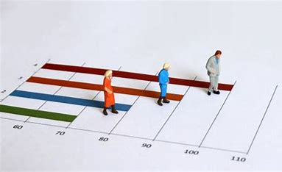

Figure 3.1. Life Expectancy

* **Data Composition:**

**1. Primary Attributes:**

* Country: The name of the country.
* Year: The year for which data is recorded.
* Life Expectancy: The average number of years a newborn is expected to live.
* Adult Mortality: The probability of dying between the ages of 15 and 60 per 1000 population.
* Infant Deaths: The percentage of under-one-year-old deaths for every 1000 live births.

**2. Health Indicators:**

* Alcohol: Recorded per capita (age 15+) consumption (in liters of pure alcohol).
* BMI: Average body mass index of the population.
* Hepatitis B: Immunization coverage among one year olds (%).
* Measles: Number of reported cases per year.
* Polio: Immunization coverage among one year olds (%).
* Diphtheria: Immunization coverage among one year olds (%).

**3. Economic and Social Indicators:**

* GDP: Gross Domestic Product per capita.
* Income Composition of Resources: A composite index aggregating income.
* Schooling: Average number of years of schooling.
* Status: Status of the country's economy (Developed or Developing).

**4. Mortality and Fertility Rates:**

* Under Five Deaths: The number of deaths of children under five years of age.
* HIV/AIDS: Death rate from HIV/AIDS.
* Thinness 119 Years: Prevalence of thinness among children and adolescents aged 1 to 19.
* Thinness 59 Years: Prevalence of thinness among children aged 5 to 9.
* Total Expenditure: Total expenditure on health as a percentage of GDP.
* **Key Characteristics:**
* The dataset contains both numerical and categorical data.
* There are missing values in some features which need to be addressed.
* Some features might contain outliers, which could affect the analysis
* **Data Quality and Challenges:**
* Missing Values: Some fields may have missing values due to unavailable data or reporting inconsistencies.
* Inconsistencies: There could be discrepancies in data recording techniques between nations and years.
* Data Imbalance: Analyses may be impacted by differences in the availability of data between industrialized and developing nations.
* **Potential Use Cases:**
* Predictive Modeling: Developing models to predict life expectancy based on various health, economic, and social indicators.
* Correlation Analysis: Studying correlations between life expectancy and other attributes such as GDP, schooling, and health expenditure.
* Policy Impact Studies: Assessing the impact of public health policies and economic conditions on life expectancy.
* Health and Development Research: Exploring the relationship between developmental status (developed vs. developing) and life expectancy trends.
* **Metadata and Documentation:**
* Data Dictionary: An all-inclusive dictionary that describes every attribute, including potential values and significance.
* Schema Information: Detailed schema with information on data types, measurement units, and data sources.
* **Applications:**

#### ****Economic Modeling****

* **Description**: Leverages life expectancy data to understand and model the relationship between economic factors and population health.
* **Use Case**: Predict how changes in economic policies might impact life expectancy, helping policymakers make informed decisions.

#### ****Healthcare Planning****

* **Description**: Utilizes life expectancy trends to identify areas requiring healthcare improvements and resources.
* **Use Case**: Allocate resources effectively by forecasting healthcare needs in regions with lower life expectancy

#### ****Public Health Strategy****

* **Description**: Analyzes health indicators alongside life expectancy to develop targeted public health interventions.
* **Use Case**: Formulate programs to address specific health issues that lower life expectancy, such as infectious diseases or malnutrition.

#### ****Insurance Risk Assessment****

* **Description**: Uses life expectancy data to refine risk models for life insurance and health insurance.
* **Use Case**: Improve the accuracy of premium calculations and risk assessments based on demographic and health data.

#### ****Sociodemographic Studies****

* **Description**: Explores the impact of sociodemographic factors like education, employment, and living conditions on life expectancy.
* **Use Case**: Provide insights into how social policies might influence life expectancy, guiding social program development.

#### ****Environmental Impact Analysis****

* **Description**: Studies the correlation between environmental factors and life expectancy, such as air quality or water pollution.
* **Use Case**: Develop environmental regulations and initiatives aimed at improving public health and life expectancy.

#### ****Urban Planning****

* **Description**: Integrates life expectancy data into urban planning to design healthier living environments.
* **Use Case**: Plan urban infrastructure projects with a focus on factors that enhance life expectancy, like green spaces and public health facilities.

#### ****Education and Awareness****

* **Description**: Generates reports and visualizations to educate the public and raise awareness about factors affecting life expectancy.
* **Use Case**: Create educational materials for schools or public health campaigns to inform communities about healthy living practices.

**CHAPTER 4**

**4. Methodology:**

The main goal of this research is to use a multidisciplinary approach to study life expectancy statistics while concentrating on a few important goals. First, it looks at a wide range of social, economic, and health variables in an effort to pinpoint the critical elements that affect life expectancy. This entails handling issues like outliers and missing data to guarantee the quality and integrity of the dataset. By means of rigorous preprocessing and data cleaning, the research seeks to improve the dependability of ensuing analyses. Finding underlying patterns and linkages in the data through extensive exploratory data analysis (EDA) is the main goal of the research. An in-depth understanding of the ways in which many factors interact and contribute to variances in life expectancy among various people and areas will be made possible by this EDA.

The research will create reliable prediction models to estimate life expectancy based on the identified variables, building on the insights obtained via EDA. These models will provide predictive insights that can be verified against current data by utilizing cutting-edge statistical and machine learning approaches. The ultimate objective is to establish significant relationships between the variables under analysis and life expectancy, converting the results into useful suggestions for decision- and policy-makers. This project aims to promote the development of effective policies and interventions that can improve public health and life expectancy outcomes internationally by studying the critical elements that affect life expectancy.

* 1. **Data Ingestion:**



Figure 4.1. Data Ingestion

* **Upload:** Through an easy-to-use web interface, users upload a CSV file to start the process. The user-friendly interface makes it simple for users to choose their file from local storage and submit it for analysis. By offering customers clear directions and feedback during the upload process, the system ensures a flawless experience for them by supporting a wide range of file sizes and formats.
* **Temporary Storage:** The CSV file is temporarily stored on the server for later processing after it is uploaded. This safe temporary storage guarantees that the file is available for rapid data processing operations without interfering with the user's device's original file. With safeguards in place to ensure data integrity and confidentiality, the system is built to manage this storage effectively. This stage of temporary storage is essential because it enables the system to organize the file, get it ready for analysis, and make sure the data is ready for further processing.
  1. **Data Loading:**

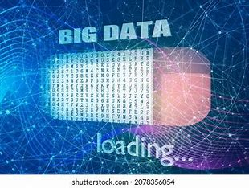

Figure 4.2. Loading Data

* **Pandas Session:** Pandas is a flexible Python package that's frequently used for jobs involving data processing and analysis. It makes managing structured data easier by offering strong capabilities for exploration, purification, and manipulation of data. First, datasets are loaded into Pandas DataFrames from different sources, such as CSV files, so that Python may easily access and manipulate them. In order to prepare data for additional analysis or modeling, it is essential to do thorough data transformations, which include addressing missing values, eliminating duplicates, and changing data types.

After it has been loaded, Pandas helps with exploratory data analysis (EDA) by calculating descriptive statistics, displaying data distributions, and spotting trends through the use of integrated plotting capabilities or by connecting with other libraries to create more sophisticated visualizations. Pandas is an essential tool for activities ranging from data preprocessing to model training and evaluation in machine learning workflows because it can do sophisticated operations like grouping, aggregating, and feature engineering, in addition to basic operations. Pandas is the tool of choice for data scientists and analysts looking for effective data handling and perceptive analytical capabilities because of its user-friendly interface and extensive capability.

* 1. **Data Exploration and Preprocessing:**



Figure 4.3 Data Processing

* **Exploratory Analysis:** First, a snapshot of the data structure and content is provided by displaying the first and last rows of the dataset. The form of the dataset (number of rows and columns), the data types (numerical, categorical) in each column, and fundamental statistics (mean, median, standard deviation, and percentiles) are all described. This stage is essential for comprehending the dataset's overall characteristics and spotting any sudden anomalies or patterns.

• **Missing Values Handling:**

1. **Identification and Imputation:** K-Nearest Neighbors (KNN) imputation is used to identify and handle missing values in numerical columns. The variance and distribution of the dataset are maintained by estimating missing values using the nearest data points. KNN imputation is advantageous because it can be more accurate than other imputation methods like mean or median substitution by filling in missing values by using local data patterns.
2. **Encoding Categorical Columns:** Label Encoding is used to address missing values in category columns by transforming the values into a numeric format. Label encoding plays a crucial role in converting qualitative data into a machine learning model-friendly format and enabling the incorporation of category variables into the study.

* **Duplicate and Garbage Values:** Duplicate rows in the dataset are checked for since they can distort analysis and compromise data integrity. By eliminating unnecessary entries, locating and summarizing these duplicates aids in data cleansing. Furthermore, illogical or out-of-range values—also known as garbage values—are recognized and compiled. In order to guarantee the precision and dependability of the analysis, cleaning these values is essential.
* **Outlier Detection and Treatment:** The Interquartile Range (IQR) approach is used to identify outliers in the dataset. By using this technique, data points that are noticeably outside the range of the majority of the data are found, which may hint to anomalies or mistakes. Outliers are recognized and dealt with accordingly, based on how they affect the analysis, either by eliminating them or changing their values. By lessening the impact of extreme results, this step aids in preserving the robustness of statistical studies and prediction models.
  1. **Data Visualization:**



Figure 4.4. Data Visualization

* **Descriptive Statistics:**
* **Visualizations:** To understand the distribution and relationships within the dataset, various graphical representations are created:

1. **Histograms:** Visualize the distribution of individual numerical variables, showing the frequency of different ranges of values.
2. **Boxplots:** Highlight the central tendency and dispersion of the data, while also identifying potential outliers within numerical columns.
3. **Scatter Plots:** Examine relationships between pairs of variables, facilitating the identification of correlations and trends.
4. **Heatmaps:** Display correlations between numerical variables through color-coded matrices, providing a quick overview of the strength and direction of relationships between variables.
   1. **Clustering:**

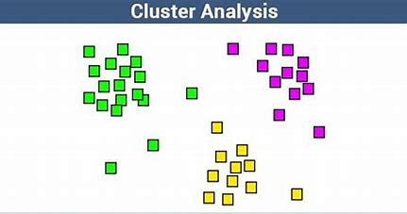

Figure 4.5. Clustering

1. **PCA Transformation:**

* **Dimensionality Reduction:** Utilizing Principal Component Analysis (PCA), the dataset's dimensionality is decreased while maintaining a high degree of variance. The data is simplified by this transformation, which makes it easier to handle for subsequent analysis and visualization.
* **Interpretation:** Principal component analysis (PCA) assists in determining the most important elements causing the variability in the data by reducing the original variables into a smaller number of uncorrelated components. This procedure can help identify the most important elements influencing life expectancy and can also reveal the underlying structure of the data.

1. **K-Means Clustering:**

* **Application:** K-Means clustering is utilized to segment the data into distinct groups or clusters based on similarities in the dataset's features.
* **Elbow Method:** Plotting the within-cluster sum of squares against the number of clusters and locating the point where the rate of reduction sharply slows down (referred to as the "elbow") allows one to establish the ideal number of clusters. By balancing compactness and separation, the number of clusters selected using this method is guaranteed to produce meaningful groups within the data.
* **Cluster Analysis:** In order to uncover common traits and patterns among the nations or regions grouped together, the resulting clusters are studied, offering insights into commonalities in their profiles of life expectancy.

1. **DBSCAN Clustering:**

* **Density-Based Clustering:** For a density-based clustering strategy, the dataset is subjected to Density-Based Spatial Clustering of Applications with Noise (DBSCAN). In contrast to K-Means, which requires the number of clusters to be specified, DBSCAN can handle clusters of different sizes and forms and can identify clusters based on the density of data points.
* **Noise Identification:** When it comes to spotting noise or outliers in the data—which may be abnormalities or extraordinary cases that don't fit neatly into any one cluster—DBSCAN is very good at this. This approach offers a strong clustering solution that can handle data irregularities better and is less sensitive to the geometry of the clusters.
* **Cluster Interpretation:** In contrast to the centroid-based clustering offered by K-Means, the resulting clusters from DBSCAN are analyzed to comprehend the density-based groupings inside the data.
  1. **Regression Analysis:**



Figure 4.6. Regression Analysis

* **Feature Encoding and Imputation:**

1. **Data Preparation:** To make model training easier, the dataset's categorical features are converted into numerical values. Depending on the type of categorical data, methods like label encoding or one-hot encoding are usually used for this.
2. **Missing Values Imputation:** Imputation techniques like KNN imputation, which estimates missing values based on the data of the nearest neighbors, are used to fill in the gaps in numerical columns containing missing data. By doing this, biases that can result from missing data are reduced and the dataset is guaranteed to be complete and prepared for model training.

• **Model Training:**

* **Linear Regression Model:**

1. **Training:** Based on the supplied features, a Linear Regression model is developed to predict life expectancy. The dependent variable (life expectancy) and the independent variables (predictors) in this model are shown to be linearly related.
2. **Interpretation:** Insights into how each predictor influences life expectancy are provided by the coefficients obtained from the Linear Regression model, which aid in identifying important factors and their effects.

* **Random Forest Model:**

1. **Training:** Additionally trained to predict life expectancy is an ensemble learning technique called Random Forest. In order to improve predictive performance and lessen overfitting, this model constructs numerous decision trees and aggregates their results.
2. **Feature Importance:** The Random Forest model yields feature importance ratings that indicate the variables that have the greatest impact on life expectancy prediction. This makes it easier to see how important various parameters are in relation to the predictions made by the model.

* **Model Evaluation:**

1. **Mean Squared Error (MSE):** The Mean Squared Error (MSE), which calculates the average squared difference between the values of actual and anticipated life expectancy, is used to assess the performance of both models. Better model performance, which reflects more accurate predictions, is shown by a lower MSE.
2. **R-squared (R²):** The performance of the model is also assessed using the R-squared (R²) statistic. This statistic shows the percentage of the dependent variable's variance that the model's independent variables account for. An R2 value that is closer to 1 indicates that the model has a stronger explanatory power and more accurately represents the variability in life expectancy.
3. **Comparison and Insights:** One can learn more about the relative predictive power and prediction robustness of the Random Forest and Linear Regression models by comparing their MSE and R2 values. Decisions on the selection and improvement of the model are informed by this comparison.
   1. **Insight Generation:**



Figure 4.7. Insight Generation

* **Feature Importance:**

1. **Identification of Key Features:** It is critical to identify the features that have the greatest impact on life expectancy while analyzing data on life expectancy. In order to do this, feature significance metrics obtained from the Random Forest model are examined. These metrics assist identify the factors that have the most effects on life expectancy by showing the relative contributions of each characteristic to the model's predictions.
2. **Visualization:** Bar plots and other graphical techniques are commonly used to depict the significance of individual features, facilitating the interpretation of the most relevant aspects. Higher relevance feature scores carry greater weight in the analysis, revealing important information about the main factors influencing life expectancy.
3. **Policy Implications:** Comprehending the significance of features enables focused suggestions and policy actions. For example, policy makers can give priority to funding and reforms in the healthcare sector if it is determined that healthcare spending is a significant factor in determining life expectancy.

* **Text Generation:**

1. **Insight Generation:** A pre-trained language model (e.g., distilgpt2) is used to produce extensive narratives based on the analysis results in order to offer thorough insights. This model is capable of synthesizing data findings and clearly and concisely showing noteworthy trends, correlations, and patterns.
2. **Automated Reporting:** Text explaining the analysis's findings, such as the connections between different socioeconomic characteristics and life expectancy, can be produced by the language model. Stakeholders without a strong technical experience can access the findings by using this text to create reports, summaries, and suggestions.
3. **Contextual Interpretation:** In addition to quantitative analysis, the language model offers interpretation and context, narrating how many factors interact to affect life expectancy. This facilitates the comprehension of the data's wider implications and supports better-informed decision-making.
   1. **Visualization and Reporting:**



Figure 4.8. Visualization

* **Visualization:**

1. **Regression Results:** Plotting the projected life expectancy values versus the actual values is one way to visualize regression results. Scatter plots and line graphs can be used to demonstrate how well the model's predictions match the actual data. Extra charts, like residuals plots, can be used to evaluate how well the model performs by emphasizing differences between expected and observed values.
2. **Feature Importance:** Bar charts or significance plots that rank features according to how much they contribute to life expectancy prediction are used to show the importance of a feature. These graphics facilitate the interpretation and dissemination of the model's results by making it simple to determine which factors have the greatest impact on life expectancy.
3. **Cluster Analysis:** Data points colored according to cluster membership are shown in scatter plots, which are used to visualize clustering results (such as K-Means and DBSCAN). Elbow plots illustrate the change in within-cluster sum of squares for varying cluster counts, which aids in determining the ideal number of clusters for K-Means clustering.
4. **Dimensionality Reduction:** Biplots and scree plots are two ways that results from Principal Component Analysis (PCA) are displayed. Biplots give information about the variation that each component captures by showing the principal components and the data points projected onto these components. Scree charts assist in determining the number of components to keep by displaying the explained variance for each primary component.
5. **Descriptive Statistics:** A thorough understanding of the data distribution, correlations, and relationships between variables is provided by the use of histograms, boxplots, scatter plots, and heatmaps. These visual tools identify patterns, anomalies, and trends in the dataset, which helps with the exploratory investigation.

* **HTML Rendering:**

1. **Web Interface Display:** HTML is used to render the analysis's results, including all of the visualizations and important conclusions, on a web interface. Users may now engage directly with the data and insights using their web browsers thanks to this.
2. **Embedded Images:** Graphs and charts, among other visualizations, are incorporated into HTML pages via image tags or data URIs. This guarantees that all pertinent visual content is included into the online interface with ease, rendering the analysis results aesthetically pleasing and easily accessible.
3. **Interactive Components:** To improve the user experience, interactive features like tooltips, zoomable charts, and clickable maps can be added. These elements give users the opportunity to go further into the data and interact dynamically with the analysis's conclusions.
4. **Responsive Design:** Because of its responsive design, the web interface may be accessed on a range of devices, such as smartphones, tablets, and desktop computers. By doing this, the analysis's scope is increased and stakeholders can more easily access and comprehend the findings on any device.

### Architecture Diagram

Dataset

Figure 4.9. Architecture Diagram

The architecture description is as follows:

1. **Frontend and User Interaction:**

* **File Upload:**

1. **User Interface for CSV Upload:** The application provides an intuitive interface where users can upload their CSV files containing life expectancy data. This feature is designed to be user-friendly, allowing users to simply drag and drop their files or browse their directories to select the file for upload.
2. **Validation and Feedback:** Upon uploading a file, the system validates the format to ensure it meets the required specifications. If any issues are detected, such as incorrect file format or missing columns, users receive immediate feedback to correct the issue. This helps in maintaining data integrity and prepares the dataset for analysis.
3. **Progress Indicators:** The interface includes progress indicators that inform users about the status of their file upload and processing, enhancing the user experience by providing transparency on the operations being performed.

* **Visualization:**

1. **Interactive Data Visualizations:** Users are presented with a suite of interactive visualizations that provide deep insights into the uploaded life expectancy data. These include:
2. **Histograms:** Display the distribution of numerical features such as life expectancy, income, and healthcare access across different regions and time periods.
3. **Scatter Plots:** Illustrate relationships between key variables, allowing users to explore correlations such as the impact of economic factors on life expectancy.
4. **Boxplots:** Highlight the spread and outliers in the data, providing a clear view of the variability within key metrics across different groups.

• **Text Insights:**

1. **Generated Textual Summaries:** Alongside visualizations, the application presents textual insights that summarize key findings from the analysis. These summaries are generated using advanced language models and provide contextual explanations of the data patterns observed.
2. **Actionable Recommendations:** The text insights not only describe the data but also provide actionable recommendations based on the analysis. For example, they may highlight critical areas for policy intervention or suggest strategies for improving life expectancy based on identified trends.
3. **Narrative Generation:** The system is capable of generating narratives that contextualize the data within broader trends and historical data. This helps users understand the implications of the data in a real-world context, making the insights more impactful and easier to communicate to stakeholders.

* **Technologies**:
* **Flask:**

1. **Web Framework:** Flask is utilized as the core web framework to handle server-side logic and manage routes. It orchestrates the backend processes, including handling file uploads, executing data analysis tasks, and serving HTML pages.
2. **API Integration:** Flask also facilitates API integrations for data processing and visualization, allowing seamless communication between the frontend and backend.

• **HTML:**

1. **Markup Language:** HTML is employed to structure the web pages, defining the layout and content of the user interface. It ensures that the various elements such as forms, visualizations, and text panels are well-organized and accessible.
2. **Templates:** Flask uses Jinja2 templates to render dynamic HTML content, allowing for the integration of data-driven elements and user-specific information into the web pages

.

• **CSS:**

1. **Styling:** CSS is used to style the HTML elements, providing an aesthetically pleasing and consistent look and feel across the application. It handles the design aspects, including colors, fonts, and layout positioning, to enhance user experience.
2. **Responsive Design:** CSS ensures that the application is responsive, making it accessible on various devices, from desktops to mobile phones, by adapting the layout to different screen sizes.

• **JavaScript:**

1. **Interactivity:** JavaScript adds interactivity to the web application, enabling dynamic features such as interactive data visualizations and real-time updates. It enhances user engagement by allowing users to interact with the data visualizations, filter results, and view detailed information.
2. **Libraries and Frameworks:** JavaScript leverages libraries and frameworks such as D3.js or Chart.js for creating sophisticated and interactive graphs and charts. It also handles AJAX requests for asynchronous data loading and updating without reloading the page.

* **Bootstrap:**

1. **Responsive Framework:** When creating responsive web pages, Bootstrap is utilized to make sure that the layout works well on a variety of devices, such as tablets, smartphones, and PCs.
2. **Components and Utilities:** With the help of a variety of pre-made elements and utility classes like buttons, forms, modals, and grids, Bootstrap speeds up development and preserves consistency in application design.
3. **Customization:** The application may retain its distinctive appearance while utilizing the responsive features and strong grid structure of the framework thanks to Bootstrap's ability to customize themes and styles.

* **Key Components**:
* **Upload Form:**

1. **CSV File Submission:**
2. **User Input:** Provides a user-friendly interface for uploading CSV files containing life expectancy data. Users can drag and drop their files or use a traditional file picker.
3. **Validation:** The form includes validation checks to ensure that the uploaded file meets the required format specifications. This prevents errors during data processing and analysis.
4. **File Handling:** Upon submission, the file is temporarily stored on the server for further processing. The system handles file management securely, ensuring that user data is protected and processed efficiently.

* **Visualization Pages:**

1. **Graphs and Charts Rendering:**
2. **Data Visualizations:** These pages render various types of graphs and charts based on the uploaded data. Users can explore histograms, scatter plots, boxplots, and choropleth maps that provide insights into life expectancy trends and related variables.
3. **Interactivity:** The visualizations are interactive, allowing users to zoom in on specific data points, filter results by different criteria, and view detailed information by hovering over or clicking on elements.
4. **Customization Options:** Users can customize the visualizations by selecting different variables, adjusting scales, and applying filters. This makes it easy to tailor the analysis to specific needs and preferences.

* **Insight Panels:**

1. **Textual Insights and Summaries:**
2. **Generated Insights:** Display panels that present textual summaries of the analysis results. These insights are generated from the data and provide contextual explanations, highlighting key findings and trends.
3. **Recommendations:** The panels may also include actionable recommendations based on the data analysis, such as policy suggestions or areas for further investigation.
4. **Dynamic Content:** The insights are dynamically updated based on the user's data and interactions, ensuring that the information presented is relevant and current.
5. **Narrative Generation:** Advanced language models generate narratives that contextualize the data within broader trends, offering users a deeper understanding of the implications and helping them make informed decisions.
6. **Backend Processing**:

**Purpose**: Manages data processing, model execution, and result delivery.

* **API Endpoints (Flask Routes)**:
* **upload**: By accepting CSV files uploaded via the web interface, this endpoint manages the first phase of the data pipeline. The /upload route verifies that a file uploaded by a user is a legitimate CSV file by validating the file format. After that, the uploaded file is momentarily stored on the server for later handling. In this step, the file's content and structure are examined to make sure the anticipated data fields required for further analysis are there. The user may receive a confirmation message from the system after a successful upload and validation, letting them know that their file has been approved and is now available for additional examination.
* **summary**: A thorough summary of the uploaded data is provided by the /summary endpoint. By loading the CSV file into a Pandas DataFrame
* for in-depth analysis, it starts the exploratory data analysis (EDA) process. Many descriptive statistics, including dataset form, data kinds, and fundamental metrics like mean, median, and standard deviation for numerical columns, are generated and returned by this method. It also finds missing values and summarizes how they are distributed throughout the collection. This synopsis facilitates comprehension of the overall properties of the data and helps spot possible problems, including inconsistent or missing information, that would need to be fixed before a more thorough study.
* **visualization**: Several different visual representations of the dataset are produced and returned by this endpoint. In order to show the distributions and relationships within the data, the /visualization route takes the processed data and produces graphical outputs like histograms, boxplots, scatter plots, and heatmaps. Additionally, it compiles statistics on life expectancy by nation and displays the results using graphic aids such choropleth maps. It generates pie chart-like visualizations for development status analysis, which displays the distribution of nations according to their level of development. These data visualizations are essential for understanding the data in a way that is easier to understand and more accessible, enabling users to recognize trends, patterns, and outliers with greater accuracy.
* **predict**: Predictive models are executed on the prepared data by the /predict endpoint. This method uses models like Linear Regression and Random Forest to predict life expectancy after handling feature encoding and imputation for missing values. Using measures like Mean Squared Error (MSE) and R-squared (R²), it assesses these models' performance and provides a numerical evaluation of their effectiveness. It also finds and returns the most significant characteristics that have an impact on life expectancy. In order to help with decision-making and policy development, the user receives the predictions back along with comprehensive insights and visualizations of the regression results and feature importance. This allows for a deeper knowledge of the factors impacting life expectancy.
* **Key Components**:
* **Data Handling:** Converts uploaded files to Pandas DataFrame.

The system loads data into a Pandas DataFrame to begin data handling after receiving a CSV file via the /upload API. Given Pandas' extensive toolkit for data manipulation and its compatibility with other Python-based data science packages, this conversion makes more in-depth analysis and manipulation easier. The strengths of Pandas are used in this two-step procedure to ensure effective and adaptable data management.

* **Processing Scripts:** Scripts for data cleaning, transformation, and modeling.

A number of scripts are used in the processing pipeline to handle different phases of data preparation and analysis. These scripts contain data cleaning processes that handle missing values using techniques like KNN imputation for numerical columns, eliminate duplicates, and use Label Encoding to encode categorical variables. They also go over the processes involved in data transformation, including as feature extraction, scaling, and dimensionality reduction methods like PCA. The scripts use clustering methods like K-Means and DBSCAN for modeling, as well as machine learning algorithms like Random Forest and Linear Regression. These scripts make sure that the data is properly prepared for precise analysis and trustworthy predictive modeling, which makes it easier to produce insightful findings.

* **Response Handlers:** Prepares and formats the response data for the frontend.

A number of scripts are used in the processing pipeline to handle different phases of data preparation and analysis. These scripts contain data cleaning processes that handle missing values using techniques like KNN imputation for numerical columns, eliminate duplicates, and use Label Encoding to encode categorical variables. They also go over the processes involved in data transformation, including as feature extraction, scaling, and dimensionality reduction methods like PCA. The scripts use clustering methods like K-Means and DBSCAN for modeling, as well as machine learning algorithms like Random Forest and Linear Regression. These scripts make sure that the data is properly prepared for precise analysis and trustworthy predictive modeling, which makes it easier to produce insightful findings.

#### ****Data Processing & Modeling Layer****

**Purpose**: Handles data exploration, cleaning, analysis, visualization, and predictive modeling.

1. **Data Ingestion**:

* **Pandas**: Data is first ingested by Pandas and processed. For exploratory data analysis (EDA), Pandas provides a full range of tools, such as data manipulation, descriptive statistics, and sophisticated visualization features. It makes thorough analysis and quick prototyping possible by enabling fine-grained data operations including merging, filtering, and grouping. Additionally, Pandas easily interfaces with visualization libraries such as Seaborn and Matplotlib, allowing a wide range of plots and charts to be created for data visualization.

1. **Data Cleaning & Transformation**:

* **Missing Value Analysis**: Detects and handles missing values.

In order to guarantee the accuracy and comprehensiveness of the dataset, managing missing data is an essential step in data preparation. The procedure entails methodically locating any data gaps and choosing the most effective course of action to close them. To fill in the blanks, procedures like imputation, deletion, or model-based approaches are used. Numerical columns, for example, could be imputed using methods such as K-Nearest Neighbors (KNN), which forecasts missing values by comparing them to other data points. By keeping the dataset resilient, this phase helps to prevent biases and mistakes from entering the data and prepares it for further analysis and modeling.

* **Outlier Detection**: Identifies and treats outliers.

The outcomes of statistical analysis and predictive models can be considerably distorted by outliers. Statistical techniques like the Interquartile Range (IQR) or Z-scores are sometimes used to detect these anomalies in order to pinpoint data points that significantly depart from the norm. Depending on the situation and the effect on the study, outliers can be dealt with using a variety of techniques, including transformation, capping, or eradication. When outliers are handled appropriately, the representativeness of the data is maintained, producing more accurate and trustworthy insights.

* **Encoding**: Converts categorical variables using Label Encoding and One-Hot Encoding.

It is necessary to convert categorical variables into numerical representations that models can understand. Techniques of encoding are used to accomplish this. Label encoding is appropriate for ordinal data with meaningfully arranged categories since it gives each category a distinct numerical value. Conversely, One-Hot Encoding ensures that no ordinal relationship is suggested by creating binary columns for each category. For nominal data, this technique is crucial because it enables models to comprehend categorical differences without inadvertently adding bias.

* **Imputation**: Fills missing values using KNNImputer.

Imputation uses the patterns and relationships in the dataset to predict and fill in the gaps left by missing data. Specifically, the K-Nearest Neighbors algorithm is used by the KNNImputer to estimate missing values. It makes predictions about the missing values by looking at the 'k' nearest neighbors in the dataset and using the most similar data points. This technique improves the consistency and completeness of the dataset by producing more accurate imputed values by utilizing the natural structure and correlation present in the data.

1. **Exploratory Data Analysis (EDA)**:

* **Visualization**: Uses Matplotlib and Seaborn for static plots, and Plotly for interactive visualizations.

Understanding data distributions, correlations, and trends requires the use of visualization. Static visuals like scatter plots, boxplots, and histograms are made with Matplotlib and Seaborn and provide publication-quality insights into the data. For conducting exploratory data analysis (EDA) and spotting trends, these libraries offer intricate and visually appealing visuals.

Plotly is used for interactive visualizations. It makes it possible to create dynamic, interactive graphs that let users thoroughly examine data points, like choropleth maps and 3D scatter plots. By directly manipulating the visuals, these interactive features improve user engagement and offer a more intuitive understanding of complicated statistics, making it simpler to spot patterns and anomalies.

* **Correlation Analysis**: Examines relationships between variables using heatmaps.

The degree and direction of links between variables within the dataset are determined using correlation analysis. These relationships are shown visually through heatmaps, which display correlation coefficients in a grid style with the correlation strength indicated by the color intensity of each dot. Fast identification of highly correlated variables is made possible by this visualization, which is useful for feature selection and the detection of multicollinearity problems in predictive modeling. Through the analysis of the heatmap, analysts can ascertain the interrelationships between various factors, hence facilitating the development of more informed features and models.

1. **Modeling**:

* **Linear Regression**: Simple predictive model for life expectancy.

A basic method for estimating life expectancy based on one or more independent factors is to use linear regression. According to this model, there is a linear relationship between the predictors (such as GDP and healthcare spending) and the dependent variable (life expectancy). It offers insights into how certain factors impact life expectancy and is simple to understand. Because it is easy to use and allows for a straightforward interpretation of coefficients to establish the impact of each element, linear regression is an excellent place to start when trying to understand the fundamental impacts on life expectancy.

* **Random Forest Regressor**: Advanced model for better prediction accuracy.

An increasingly effective and complex approach to life expectancy prediction is provided by the Random Forest Regressor. Compared to linear models, this strategy increases prediction accuracy and robustness by building several decision trees and averaging their outputs. It performs better when non-linear relationships and noisy data are present and can manage intricate feature interactions. In order to determine the most important elements affecting life expectancy, Random Forest further evaluates feature importance.

* **Clustering**: Applies K-Means and DBSCAN for clustering countries based on life expectancy and other factors.

Using clustering algorithms, nations are grouped according to shared characteristics such as life expectancy and related aspects. Using K-Means Clustering, countries are divided into discrete groups based on the variation within the clusters. With the use of this technique, homogeneous groupings of nations with comparable life expectancy characteristics may be found, which is helpful for focused policy actions. Another clustering approach, called DBSCAN (Density-Based Spatial Clustering of Applications with Noise), finds clusters based on the density of data points, enabling the identification of clusters with any shape and efficient management of noise. When there are clusters in the dataset that differ in density and form, DBSCAN is especially helpful.

* **PCA**: Reduces dimensionality for visualization purposes.

The Principal Component Analysis (PCA) technique is utilized to decrease the dataset's dimensionality while preserving the majority of its variation. By transforming the original variables into a smaller set of uncorrelated components, PCA simplifies the dataset, making it easier to display and analyze. By assisting in the identification of patterns and trends in high-dimensional data, this technique makes it possible to cluster and visualize countries according to their life expectancy and related parameters more effectively. In order to support the next grouping and analysis efforts, PCA helps identify the most important underlying structures in the data.

1. **Insight Generation**:

* **Text Generation**: Uses a pre-trained model to generate human-readable insights from analysis results.

Pre-trained models are a great tool for transforming complex data insights into comprehensible summaries and explanations through text production. Textual insights are automatically generated from analytic results by utilizing pre-trained models, such as OpenAI's “distilgpt2” or comparable natural language processing (NLP) models. Here are some typical uses and advantages of it:

**Process Overview:** The first step in text generation is to input pre-trained NLP models with structured data or analysis findings. These models can comprehend the context, grammar, and semantics of human language since they have been trained on enormous volumes of text data. After processing the input data, the model produces logical, contextually relevant text that clearly and understandably summarizes the analysis's conclusions.

* **Benefits:**

1. **Automation of Insights:** By automating the process of summarizing analysis results, text creation reduces the time and effort required to manually create reports or explanations.
2. **Consistency:** The style and tone of generated text are consistent, guaranteeing consistency between reports and analysis.
3. **Accessibility:** It translates technical findings into plain language so that non-technical stakeholders can understand complex data.
4. **Scalability:** Because of its scalability, this method can produce insights quickly even from huge datasets or repeated analysis activities.

## CHAPTER 5

**5.1 Implementation**

In this project, a Flask web application is implemented to analyze and generate insights from data on a structured dataset. By managing missing values, encoding categorical variables, and impute missing values, the application preprocesses the data. After that, it analyzes the data using linear regression, clustering, and descriptive statistics. To show the results, the application creates a number of visualizations, such as choropleth maps, boxplots, scatter plots, and histograms. Lastly, it generates insights based on the study using a language model that has already been trained. The application offers an easy-to-use interface for evaluating the analysis findings and submitting a CSV file.

### Data Upload and Initial Setup

#### Data Upload

To begin, the user uploads a CSV file containing information on life expectancy. A web interface makes this process easier for users by letting them choose and upload their dataset with simplicity. The program uses Python's Pandas package, which is ideal for working with tabular data in CSV format, to read the file when it has been uploaded. The upload procedure is guided by the user-friendly interface, which also verifies the file format before allowing the user to continue.

#### Loading Data

The CSV file that was uploaded is read into a Pandas DataFrame for in-depth examination and display, since Pandas provides an extensive array of instruments for modifying and investigating data.

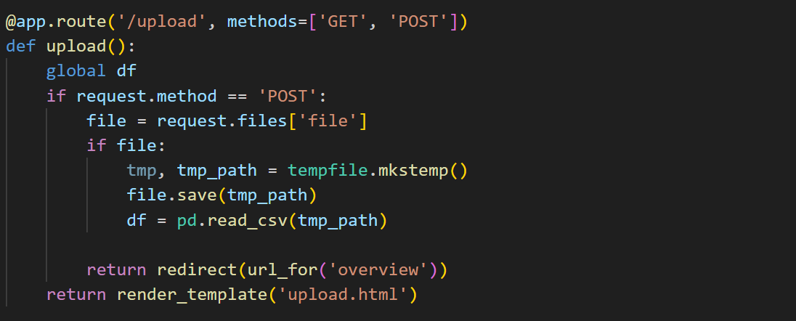

Screenshot 5.1. Loading Data

### Data Exploration and Cleaning

#### Initial Data Exploration

Investigating the fundamental structure of the dataset is the first step towards comprehending it. We examine the dataset's form (number of rows and columns), look for any missing values, and go over each column's data type using Pandas. This first investigation assists in locating any urgent problems that must be resolved before moving on to further in-depth study, such as missing or inconsistent data.

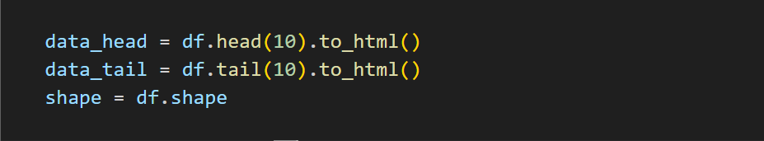

Screenshot 5.2. Data Exploration

#### Handling Missing Values

Reliability of data is essential to precise analysis. To guarantee completeness, missing values in the dataset are found and imputed. The type of data and the needs of the investigation determine which imputation approach is best. Typical techniques to fill in the missing entries are mean imputation, median imputation, or applying domain-specific knowledge. This stage guarantees that there are no gaps in the dataset that could distort the results when it is analyzed

Further.

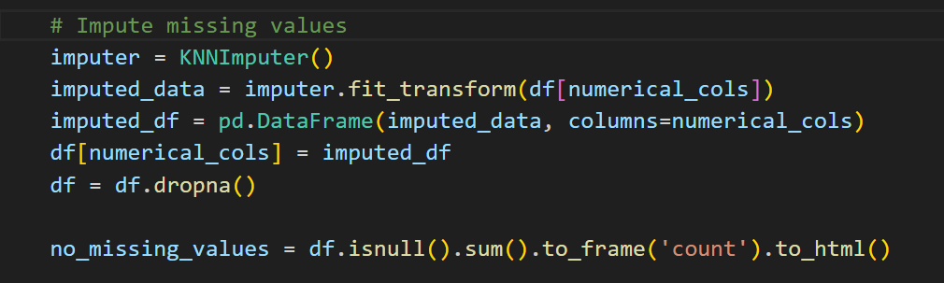

Screenshot 5.3. Handling Missing Values

#### Duplicate and Garbage Value Detection

#### To keep duplicate rows from distorting the analysis, they are eliminated. Furthermore, any trash values are found and fixed, such as non-numeric entries in numeric columns. By ensuring the dataset's integrity, this cleansing prepares it for precise analysis and display.



Screenshot 5.4. Duplicate Value Detection

#### Descriptive Statistics and Data Types

#### We validate each column's data type and compute summary statistics. This stage helps to discover possible outliers or data entry problems by offering insights into the data's central patterns and dispersion. To match the dataset with the analytic requirements, any required data type transformations are carried out.

#### 

Screenshot 5.5. Descriptive Statistics and Data Types

### Data Visualization

#### Histograms and Boxplots

For numerical variables, histograms are made to show the distributions of those variables. This aids in spotting trends like bimodal distributions, skewness, and possible outliers. Boxplots are also used to analyze the distribution and central tendency of the data, as well as to find outliers.

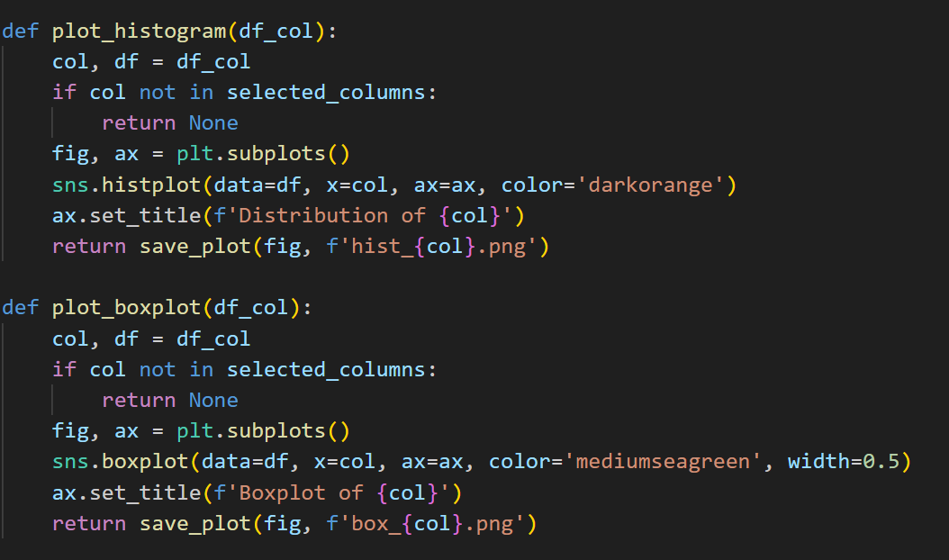

Screenshot 5.6. Histogram and Boxplots

#### Scatter Plots

Key variable correlations are examined using scatter plots. Plotting life expectancy against wealth or other factors, for example, can show trends and connections that help guide additional research. The process of generating hypotheses and identifying important variables for regression analysis is facilitated by this visual exploration.

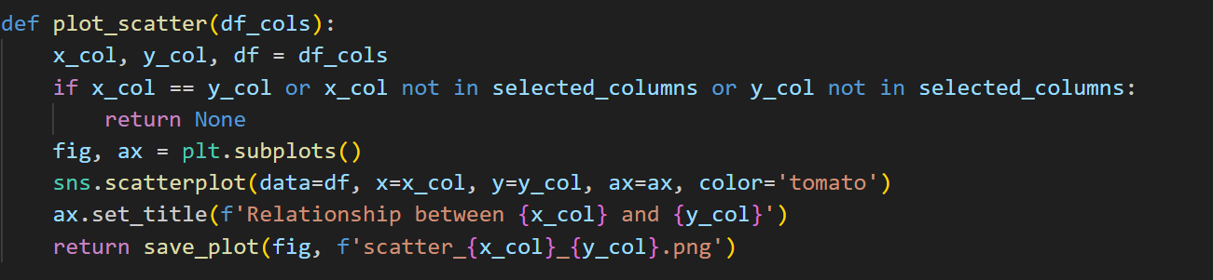

Screenshot 5.7. Scatterplots

#### Correlation Heatmap

To examine the correlations between numerical data, a correlation heatmap is made. The correlation between the variables is shown in this image, which aids in understanding the structure of the dataset and identifying good regression model predictors.

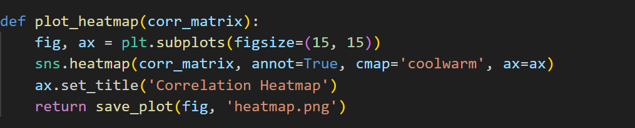

Screenshot 5.8. Correlation Heatmap

### Data Preprocessing

#### Encoding Categorical Variables

In order to make categorical variables appropriate for analysis, they are encoded. To transform categorical data into a format that can be used in regression models and other analysis, methods like one-hot encoding are utilized. By ensuring that all variables have numerical values, this step makes it easier for them to be seamlessly integrated into analytical procedures.

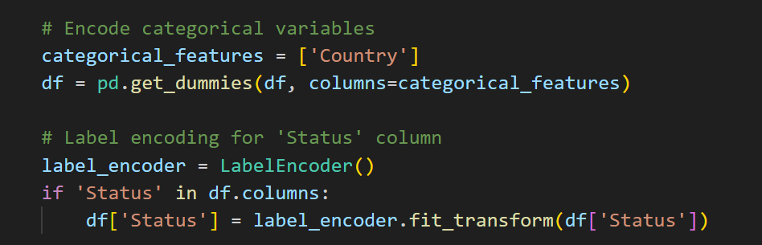

Screenshot 5.9. Encoding Categorial Variables

#### 

#### Outlier Treatment

## Outliers that have been identified are dealt with appropriately, either by being removed or having their values adjusted in accordance with the analytic needs and context. By taking this step, the analysis is less affected by extreme numbers and the conclusions are more robust.

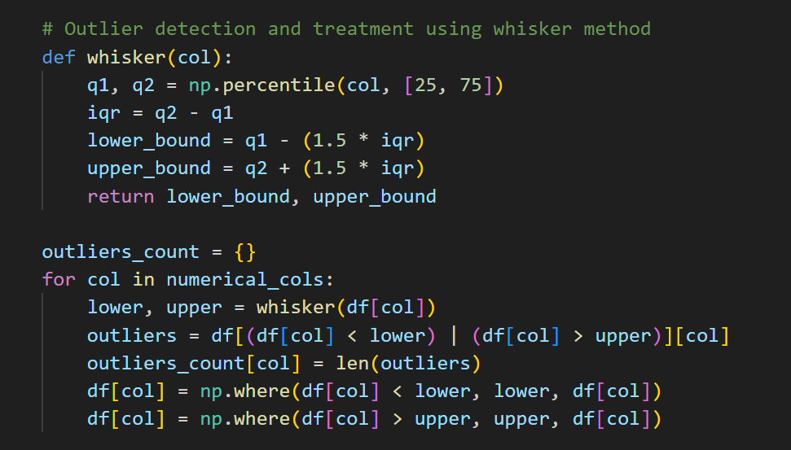

Screenshot 5.10. Outlier Treatment

### Advanced Analysis and Visualization

#### Aggregated Analysis

Analysis of aggregated data is done to find broad trends and patterns. In order to provide a high-level overview of the dataset and its features, this involves classifying data by important categories and computing summary statistics.

## Screenshot 5.11. Aggregated Analysis

### Regression Analysis

#### Linear Regression

Based on a few chosen factors, a linear regression model is constructed to forecast life expectancy. This approach offers a quantitative assessment of the influence of the major factors determining life expectancy and assists in identifying them. Metrics like Mean Squared Error (MSE) and R2 are used to assess the model's performance and offer information about its accuracy and dependability.

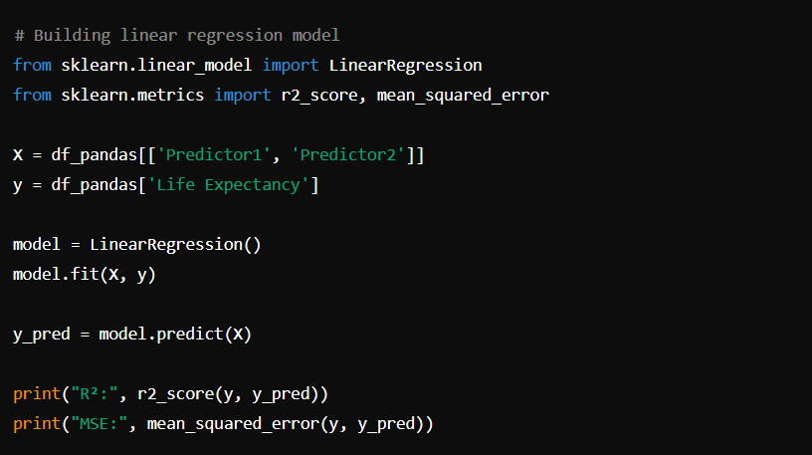

Screenshot 5.12. Linear Regression

#### Prediction Visualization

Regression model predictions are displayed next to real values in order to evaluate the model's accuracy and fit. If there are any differences between the expected and actual values, this representation aids in identifying them and can assist direct future model modification.

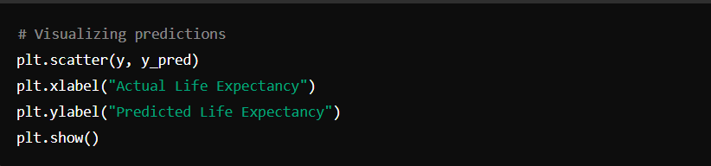

Screenshot 5.13. Prediction Visualization

### Insights Generation

#### Text Generation for Insights

Based on the analytical results, a pre-trained language model is employed to produce insights that are understandable by humans. By translating the quantitative results into descriptive summaries, this stage helps users better understand and utilize the results. Based on the data analysis, the resulting text presents a narrative that identifies important trends, patterns, and suggestions.



Screenshot 5.14. Text Generation for Insights

### Rendering Results

#### Template Rendering

The results, including visualizations and insights, are rendered in an HTML template for user interaction. This provides an intuitive interface for exploring the findings, allowing users to interact with the visualizations and review the insights in a coherent and engaging manner. The template integrates the various components of the analysis into a cohesive presentation, facilitating effective communication of the results.

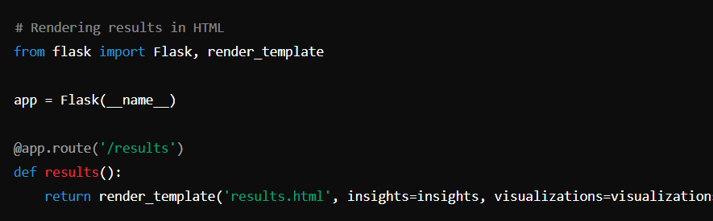

Screenshot 5.15. Template Rendering

**5.2 Results**

#### User Interface and Interaction

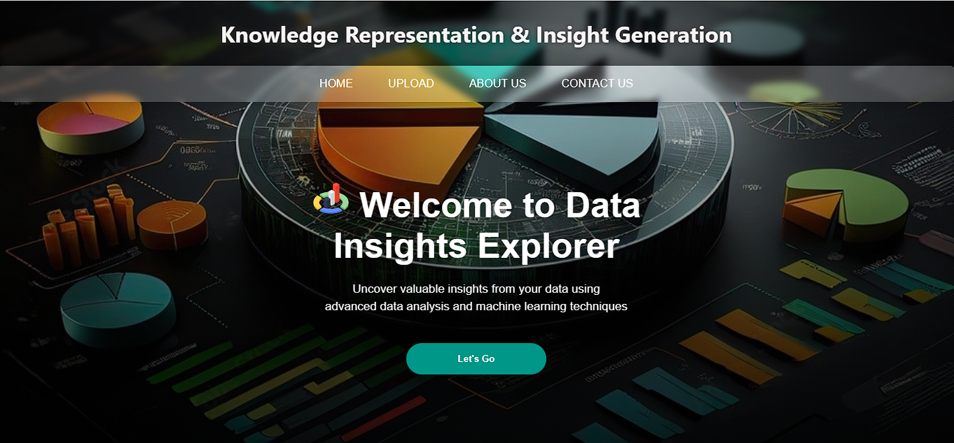The user interface (UI) of the data analysis program is designed to be easily navigable and user-friendly. Users can upload datasets, visualize data, and obtain insights via a web-based interface.

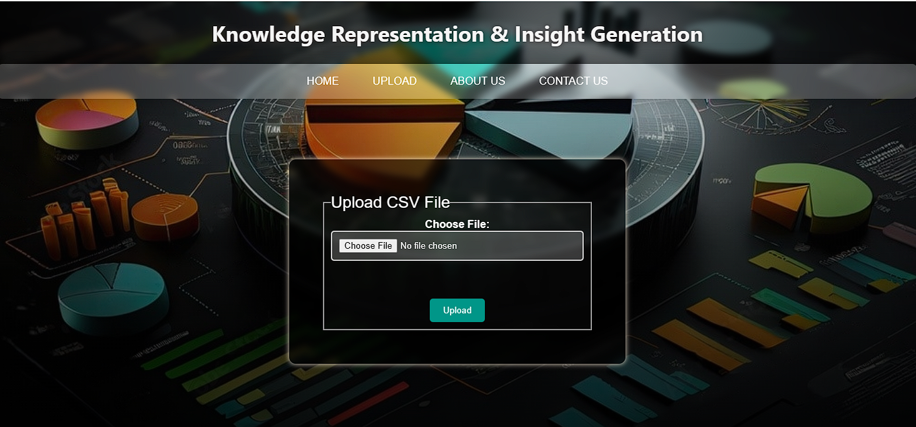

Screenshot 5.16. User Interface

#### Data Summary and Overview

The program displays a summary of the dataset that contains the first and final 10 rows after the dataset has been uploaded. Users can easily grasp the structure and type of data they are working with thanks to this overview.

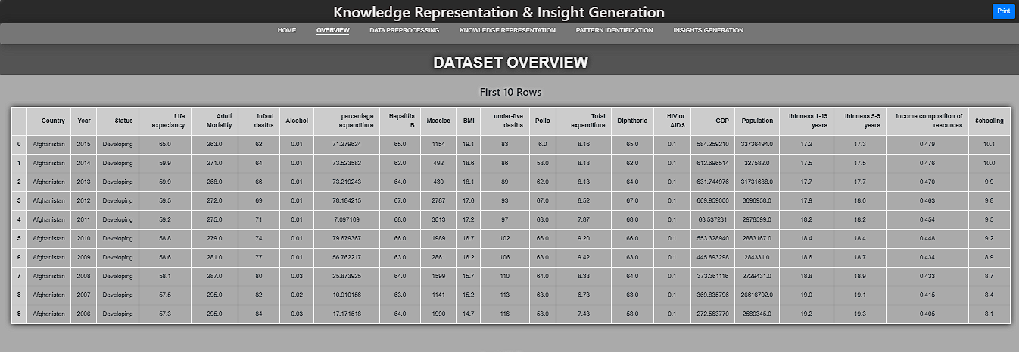Figure 5.17. Dataset Overview

* Shape and Information

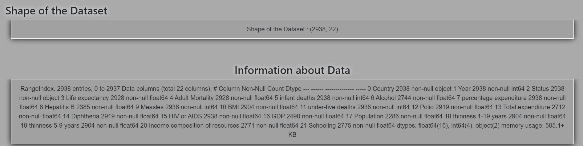Figure 5.18. Shape and Information of Dataset

#### Missing Values Analysis

#### The application identifies and reports missing values in the dataset, providing the percentage of missing data for each column. This is crucial for understanding data quality and deciding on further data cleaning steps.

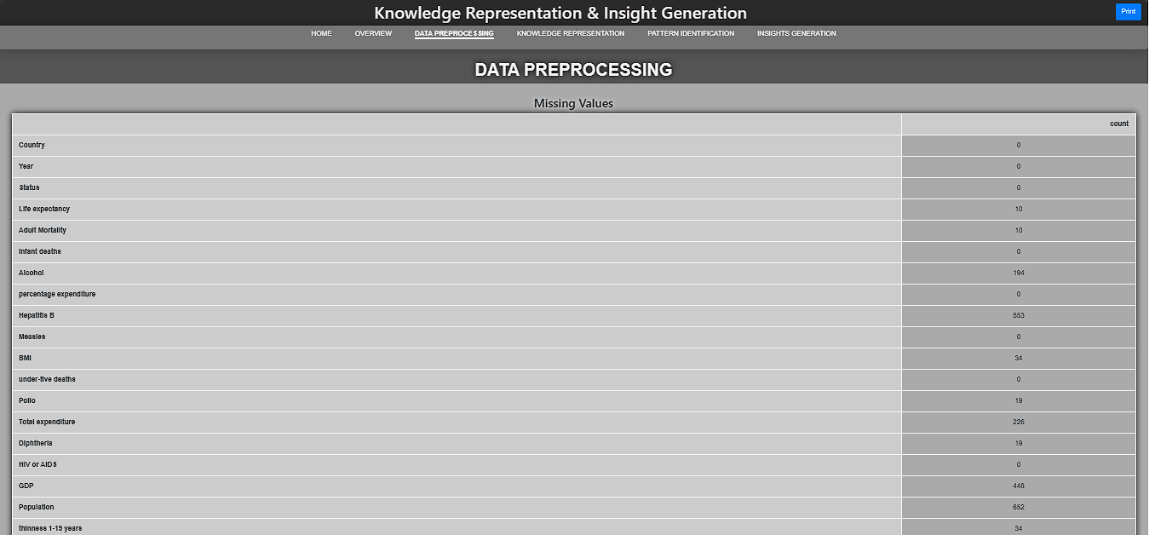Figure 5.19 Missing Values Analysis

#### Descriptive Statistics

The application determines which values in the dataset are missing and reports them, together with the proportion of missing data for each column. Understanding data quality and choosing the appropriate next actions for data cleansing depend on this.

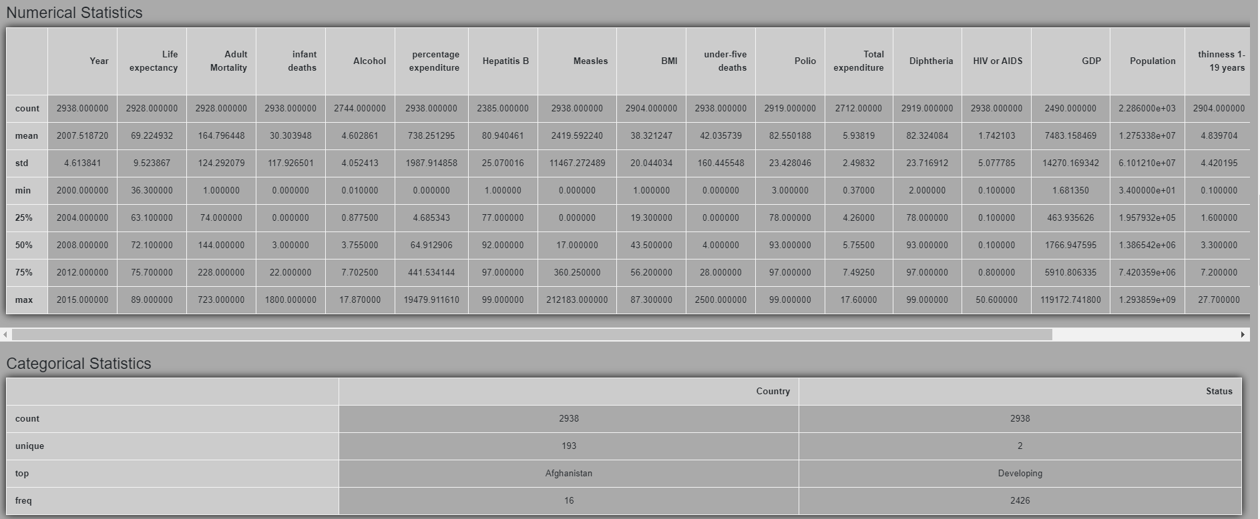Figure 5.20. Descriptive Statistics

#### Data Visualization (Before Data Preprocessing)

Heatmaps, scatter plots, and histograms are examples of data visualization features that offer visual insights into the distributions and relationships of the data.

1. Histograms (Original Data without changes):

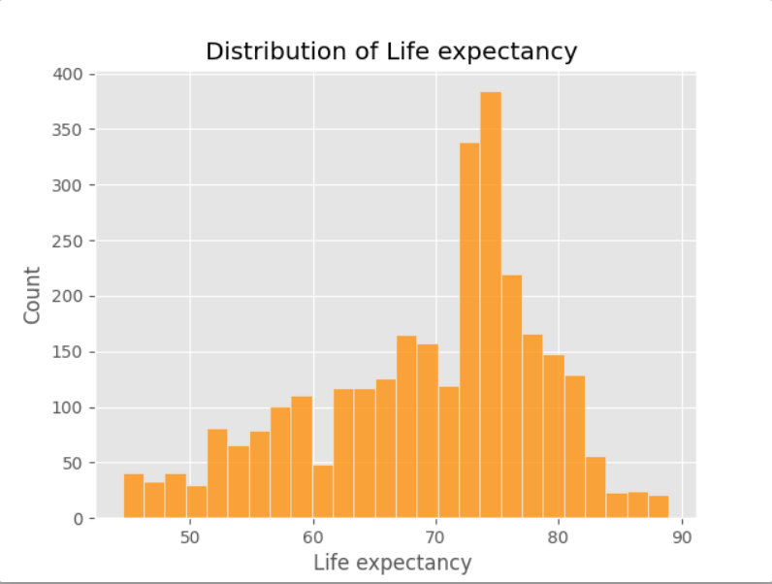A histogram is a visual representation of data distribution where bars represent the frequency of occurrences within predefined intervals or bins. It provides insights into the shape, spread, and central tendency of numerical data.

Figure 5.21. Histogram

1. Boxplots :

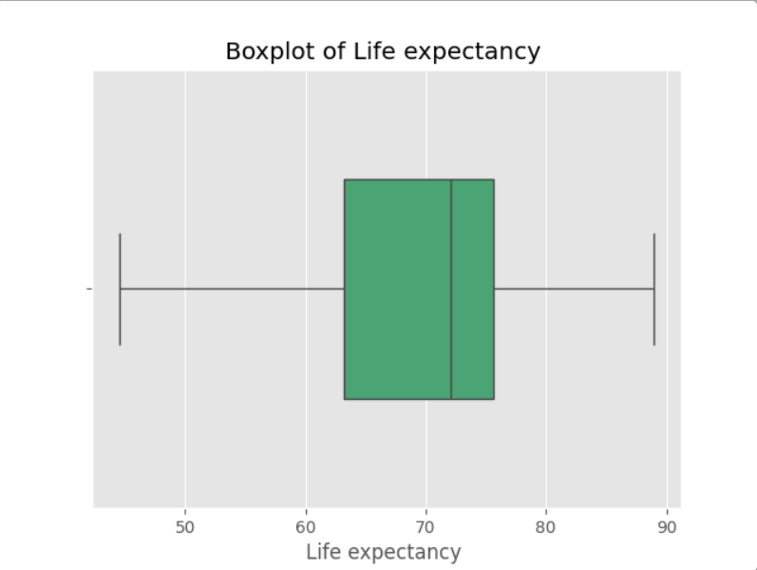A boxplot, or box-and-whisker plot, is a graphical representation of the distribution of numerical data through quartiles. It displays the median (middle value), interquartile range (middle 50% of data), and potential outliers. The boxplot is useful for visualizing data spread, skewness, and identifying outliers efficiently

Figure 5.22. Boxplot

1. Scatterplots :

A scatterplot is a type of graphical representation that displays the relationship between two continuous variables. It uses Cartesian coordinates to plot data points where each point represents a pair of values from the two variables. Scatterplots are useful for visualizing correlations or patterns in data, helping to identify trends, clusters, or outliers in the relationship between the variables.

## 

Figure 5.23. Scatterplot

1. Heatmap:

A heatmap is a graphical representation of data where values are depicted using a color gradient. It is typically used to visualize the magnitude of values in a matrix format, where colors represent different intensity levels. Heatmaps are useful for identifying patterns, correlations, or clustering in large datasets, especially when dealing with multivariate data or correlation matrices.

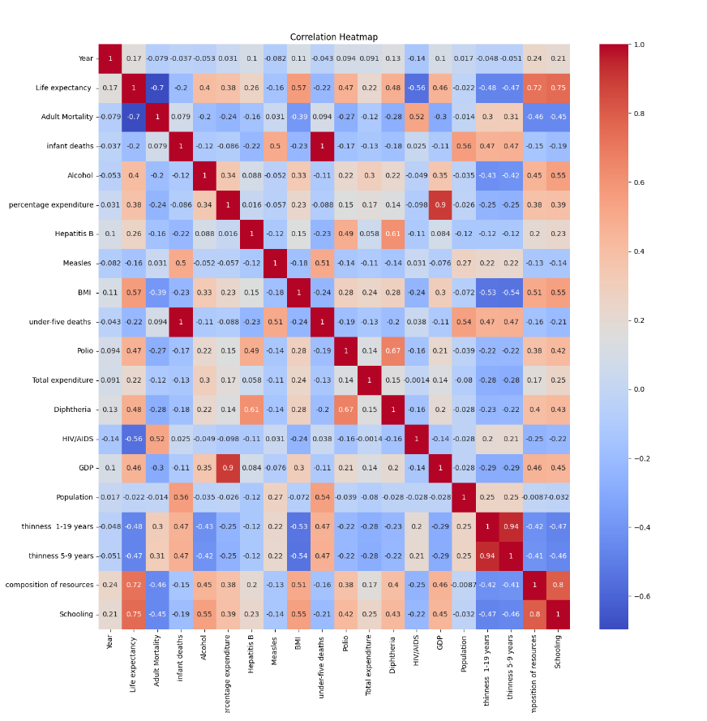

Figure 5.24. Heatmap

#### Data Cleaning and Transformation

The program handles necessary data cleansing tasks including encoding categorical variables and managing missing values. Additionally, it offers converted datasets prepared for additional modeling or analysis.

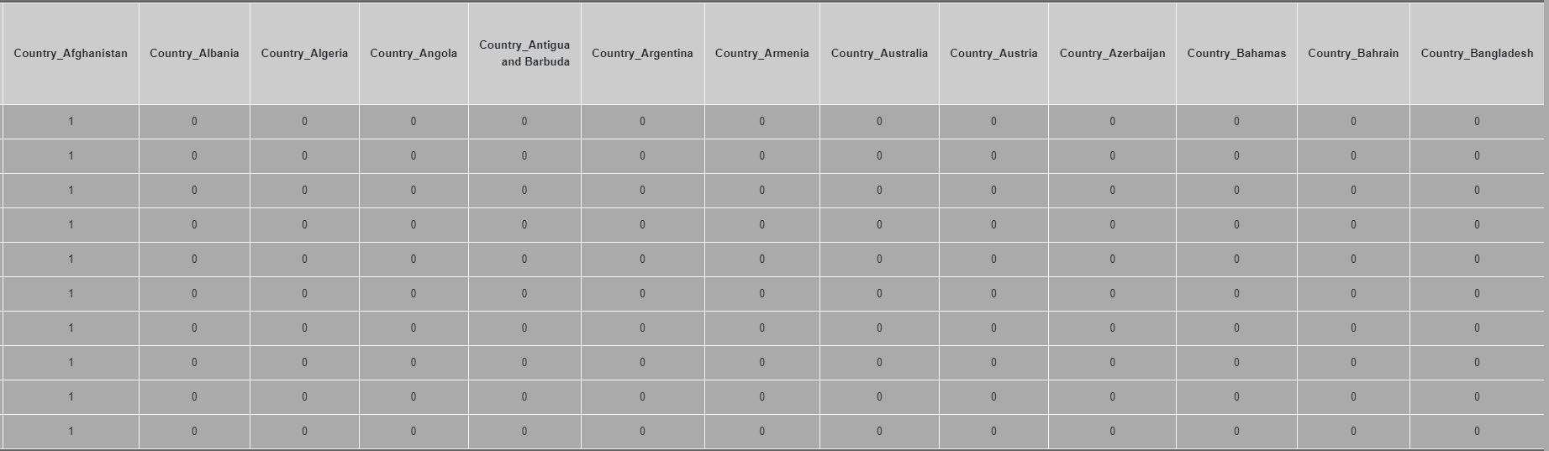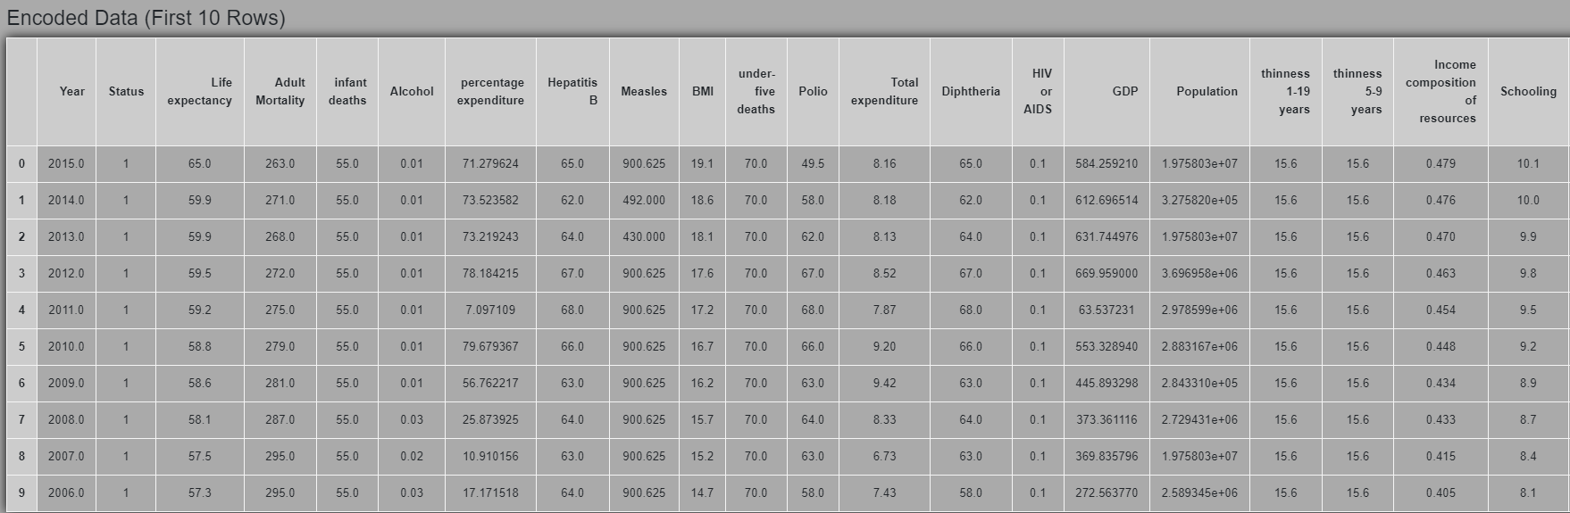Figure 5.25. Encoded Dataset

* Elbow Plot:

An elbow plot, also known as an elbow method or elbow curve, is a graphical tool used in clustering analysis to determine the optimal number of clusters. It plots the variance or another measure of clustering quality against the number of clusters. The "elbow" point on the plot indicates the optimal number of clusters where adding more clusters does not significantly improve the quality of clustering. This method helps in selecting the appropriate number of clusters to best represent the structure of the data.

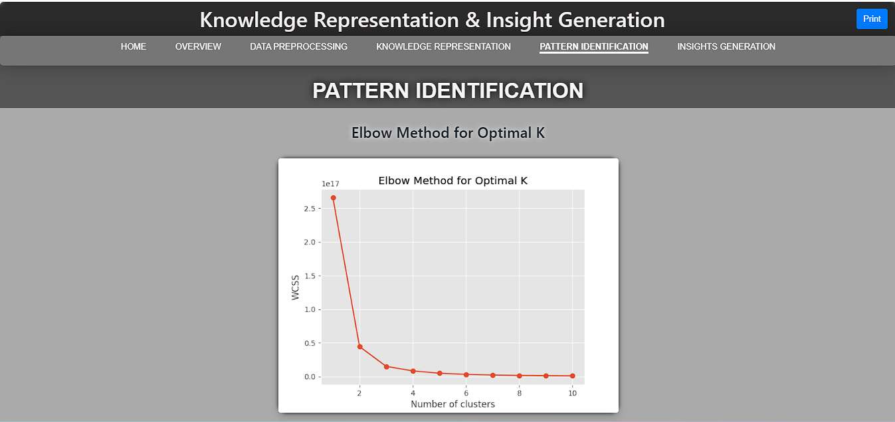

Figure 5.26. Elbow Method

* KMeans Plot

This plot helps visualize how data points are grouped into clusters based on similarity, providing insights into the clustering structure and the effectiveness of the algorithm in partitioning the data.

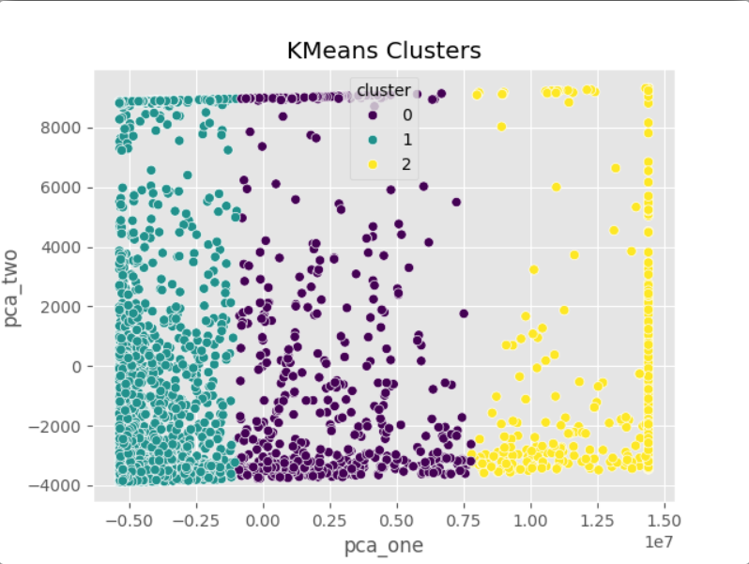

Figure 5.27. K-Means Clustering

* DBSCAN Plot:

The plot helps to visualize how DBSCAN groups data points into clusters based on density, highlighting clusters of varying shapes and sizes and identifying outliers as noise points. It provides insights into the clustering structure and density distribution within the dataset.

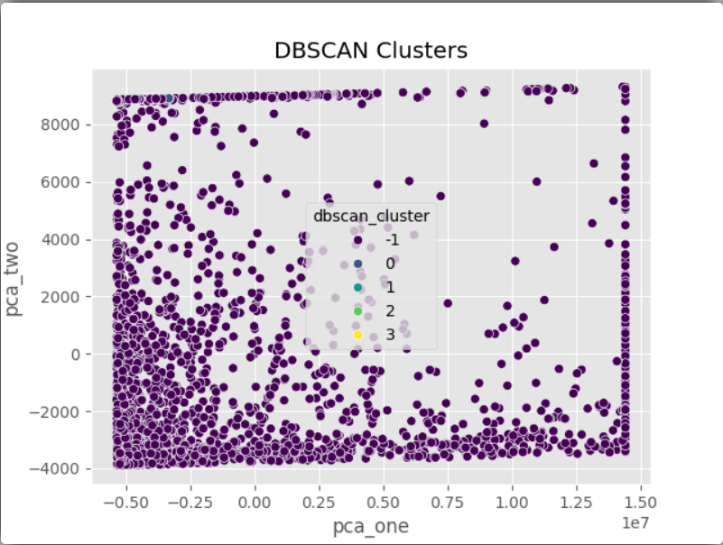

Figure 5.28. DBSCAN Clustering

* Linear Regression:

Linear regression aims to find the best-fit line that minimizes the sum of squared differences between the observed values and the values predicted by the model. It is widely used for predictive modeling, understanding relationships between variables, and making forecasts based on historical data.

Figure 5.29. Linear Regression

### Results Interpretation and Insights

#### Data Patterns and Trends

The examination of the information reveals a number of patterns and trends, including variations in life expectancy over time and the influence of healthcare costs on various health indicators.

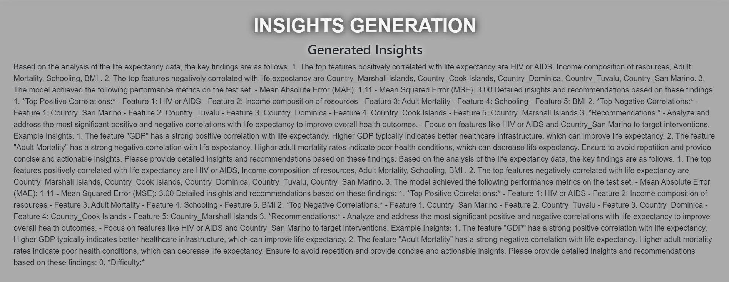

Figure 5.30. Generated Insights

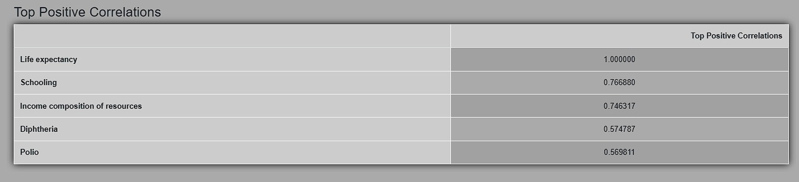

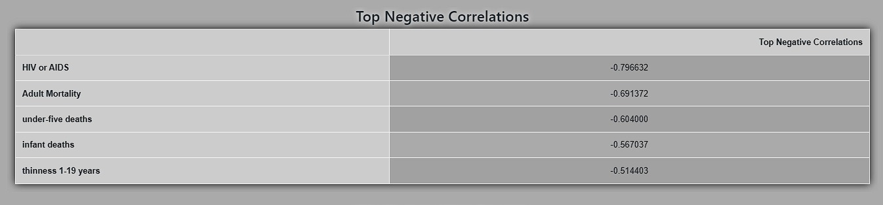

Screenshot 5.30. Positive and Negative Correlation

#### Model Results and Validation

The outcomes of these models should be discussed if the application calls for classification or predictive modeling. This comprises validation outcomes and model performance parameters including accuracy, precision, recall, and accuracy.

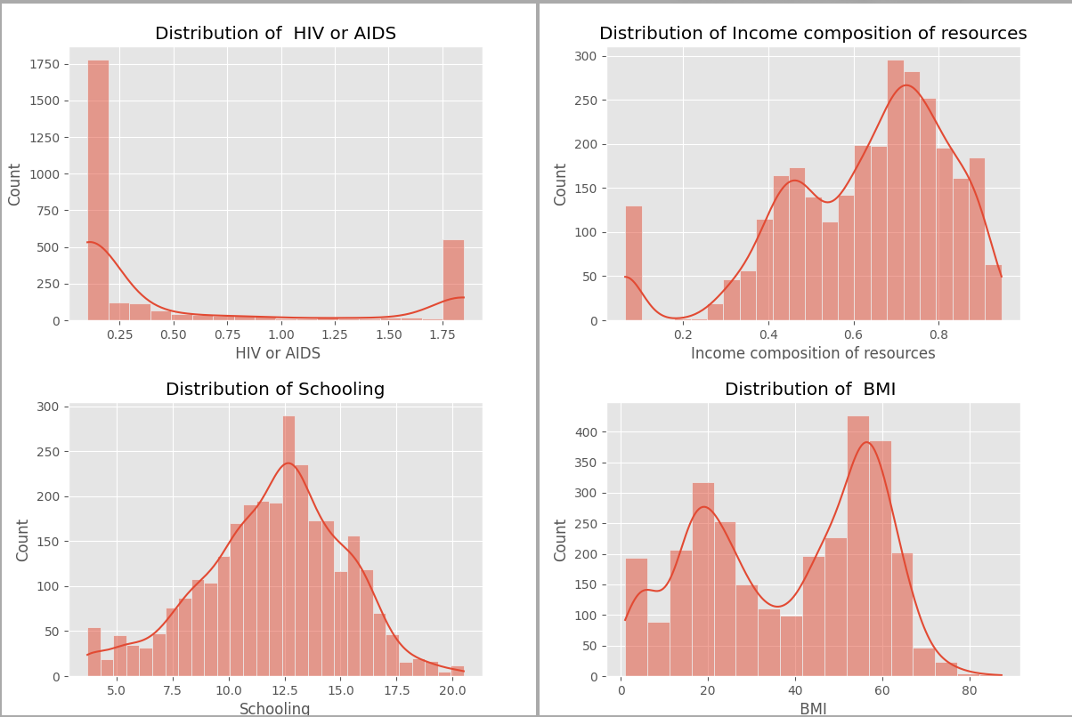

Figure 5.30. Insights Visualization

#### 5.3 Discussion

The discussion section should cover the following aspects:

* **Key Findings:** Write a summary of the main conclusions drawn from the data analysis. Emphasize any noteworthy discoveries or patterns that were found.
* **Data Quality:** Talk about the data's quality and any restrictions found during the study (such as missing data or outliers).
* **Impact of Findings:** Describe how the results might affect the relevant area or decision-making process. Talk about how plans or policies can be influenced by these discoveries.
* **Future Work:** Make recommendations for future directions for the application's development or study, such as adding more sophisticated analytic methods or growing the dataset.
* **Example Discussion Points:**
* **Life Expectancy Trends:** The data indicates an overall growth in life expectancy over the time period under study, with some variations attributed to particular healthcare crises or investments.
* **Correlation Findings:** There is a clear relationship between life expectancy and healthcare spending, suggesting that greater investment in healthcare resources generally results in better health outcomes.
* **Data Limitations:** Imputation was used to fill in the missing values in important health metrics, although more complete data would have increased the quality of the findings.

## CHAPTER 6

**6.1 Conclusion:**

This project offers an integrated framework that uses a thorough process of data pretreatment, visualization, clustering, and predictive modeling to transform life expectancy datasets into insights that can be used immediately. Scalability is ensured since the method effectively manages datasets of different sizes by combining Apache Spark and Pandas. Preprocessing techniques such as feature encoding, outlier detection and treatment, and missing value identification and imputation set the foundation for comprehensive exploratory data analysis (EDA). With the aid of visualization techniques and programs such as Matplotlib, Seaborn, and Plotly, underlying patterns and relationships can be found, providing a thorough insight of the variables affecting life expectancy. Principal Component Analysis (PCA), K-Means, and DBSCAN are examples of advanced clustering techniques that help identify important groups and variable relationships.

Accurate life expectancy forecasts are produced via predictive modeling, which uses Random Forests and Linear Regression. Model performance is assessed using measures such as Mean Squared Error (MSE) and R-squared (R²). The utilisation of a text generation model to generate comprehensible insights from analytical outcomes improves the findings' interpretability and usefulness. This combination of scalable data processing, strong analytics, and clear textual insights highlights the project's potential to successfully guide decision-making while highlighting the need to strike a balance between complex data science methods and easily understandable results communication. The research highlights how important structured data analysis is to making well-informed decisions about public health and policy, and it shows how revolutionary it may be in a number of other fields.

### 6.2 Future Scope

#### 1. ****Advanced Predictive Analytics and Machine Learning****

* **Incorporation of Advanced Algorithms**: Deep learning models or sophisticated machine learning techniques like XGBoost and Gradient Boosting could be useful in later versions of the project. These models can provide more reliable insights into the contributing factors and increase the accuracy of life expectancy projections.
* **Real-Time Predictive Analytics**: Timely insights and forecasts can be made possible by implementing real-time data processing and predictive analytics employing streaming data technologies. This would be especially helpful for dynamically tracking trends in health indices and life expectancy.

#### 2. ****Expanded Dataset Integration****

* **Inclusion of More Comprehensive Data Sources**: An investigation of the factors influencing life expectancy that is more comprehensive can be achieved by incorporating additional datasets, such as genetic data, environmental factors, healthcare quality measurements, and socioeconomic indicators.
* **Temporal Analysis**: Time-series analysis can be used to better understand how trends in life expectancy change over time and how interventions affect these trends over an extended period of time.

#### 3. ****Enhanced Data Processing and Handling****

* **Scalable Data Processing**: Using distributed computing frameworks (such as Apache Flink and Dask) to improve the scalability of the data processing pipeline can handle larger and more complex datasets, enabling more thorough analysis.
* **Automated Data Cleaning**: The preprocessing procedures can be streamlined and data quality can be increased for more accurate analysis by creating automated tools for anomaly identification and data cleaning.

#### 4. ****Interactive and Dynamic Visualization****

* **Enhanced Visualization Techniques**: Advanced visualization methods including network graphs, geographic analysis, and interactive dashboards can give users a more intuitive and in-depth knowledge of the data.
* **User-Customizable Visualizations**: Making the analysis more relevant and approachable for a wider range of stakeholders can be achieved by letting users design personalized visualizations according to their own requirements and preferences.

#### 5. ****Integration with Policy and Decision-Making Tools****

* **Decision Support Systems**: More effective treatments can be pushed by creating decision support systems that use data and projections to deliver practical advice to politicians and health organizations.
* **Impact Assessment Tools**: Planning and assessing public health initiatives can be aided by the development of instruments to measure the possible effects of various health policies and interventions on life expectancy.

#### 6. ****Exploration of Geospatial Analysis****

* **Geospatial Mapping**: By including intricate geographic mapping into the research, it is possible to pinpoint interventions more precisely by identifying regional variations and trends in life expectancy.
* **Spatial Clustering**: Finding clusters of areas with high or low life expectancy through the use of spatial clustering algorithms can provide light on the specific local factors affecting health outcomes.

**References:**

1. Shi et al. (2024). Supporting Guided Exploratory Visual Analysis on Time Series Data with Reinforcement Learning. IEEE Transactions on Visualization and Computer Graphics. DOI: 10.1109/TVCG.2023.3327200

2. Harinakshi Lydia et al. (2022). EDA and its Impact in Dataset Discover Patterns in the Service Sector. In Proceedings of the 2022 4th International Conference on Inventive Research in Computing Applications (ICIRCA). DOI: 10.1109/ICIRCA54612.2022.9985599

3. Huang et al. (2022). Rough‐Set‐Based Real‐Time Interest Label Extraction over Large‐Scale Social Networks. Complexity. DOI: 10.1155/2022/2072950

4. Zhao et al. (2021). Health Evaluation and Fault Diagnosis of Medical Imaging Equipment Based on Neural Network Algorithm. Computational Intelligence and Neuroscience. DOI: 10.1155/2021/6092461

5. Hilbert M., López P. (2011). The world’s technological capacity to store, communicate, and compute information. Science. DOI: 10.1126/science.1200970

6. Sagiroglu S., Sinanc D. (2013). Big data: a review. In Proceedings of the International Conference on Collaboration Technologies and Systems (CTS’13). DOI: 10.1109/cts.2013.6567202

7. Chen et al. (2009). Data, information, and knowledge in visualization. IEEE Computer Graphics and Applications. DOI: 10.1109/mcg.2009.6

8. Kahraman et al. (2013). Developing intuitive knowledge classifier and modeling of users’ domain dependent data in web. Knowledge Based Systems. Available at: [Knowledge Based Systems](https://archive.ics.uci.edu/ml/datasets/User+Knowledge+Modeling)

9. Khan et al. (2018). KNN and ANN-based recognition of handwritten Pashto letters using zoning features. International Journal of Advanced Computer Science and Applications. DOI: 10.14569/ijacsa.2018.091069

10. Sahu A. K., Dwivedi P. (2020). Knowledge transfer by domain-independent user latent factor for cross-domain recommender systems. Future Generation Computer Systems. DOI: 10.1016/j.future.2020.02.024

11. Desimoni F., Po L. (2020). Empirical evaluation of linked data visualization tools. Future Generation Computer Systems. DOI: 10.1016/j.future.2020.05.038

12. Chang J., Hwang J. (2020). The role of media in user participation: focusing on the knowledge activity in online space. Telematics and Informatics. DOI: 10.1016/j.tele.2020.101407

13. Constant J. (2019). Knowledge visualization and nano-crystal modeling geometry. Applied Surface Science. DOI: 10.1016/j.apsusc.2018.12.198

14. Luo W. (2019). User choice of interactive data visualization format: the effects of cognitive style and spatial ability. Decision Support Systems. DOI: 10.1016/j.dss.2019.05.001

15. Gebremeskel and Biazen (2019). Architecture and optimization of data mining modeling for visualization of knowledge extraction: patient safety care. Journal of King Saud University - Computer and Information Sciences.

16. Guo et al. (2020). An open source TrajAnalytics software for modeling, transformation and visualization of urban trajectory data. Proceedings of the IEEE Intelligent Transportation Systems Conference (ITSC). DOI: 10.1109/ITSC.2018.8570183

17. Guo et al. (2020). Visual data mining model for multi-source social data. Journal of Visual Languages and Computing. DOI: 10.1016/j.jvlc.2020.100819

18. Grossman et al. (2020). Mind mapping vs. concept mapping: the role of user motivation in knowledge representation and sharing. Knowledge Management Research & Practice. DOI: 10.1016/j.kmrp.2020.04.009

19. Keshavamurthy et al. (2019). Deep learning techniques for visual analysis of large-scale social media data. Journal of Big Data. DOI: 10.1186/s40537-019-0218-7

20. Mejía et al. (2020). A systematic mapping study on business process variability modeling. Information and Software Technology. DOI: 10.1016/j.infsof.2020.106279

21.K. Rajarshi, "Life Expectancy (WHO)," Kaggle, 2020. [Online]. Available: https://www.kaggle.com/datasets/kumarajarshi/life-expectancy-who. [Accessed: 13-Jul-2024].

**Team Members and Contribution:**

|  |  |  |
| --- | --- | --- |
| **Name:** Pranav Rajput | **Name:** Yash Lawankar | **Name:** Yash Dighade |
| **Contribution:**  1. Data Preprocessing  2. Visualization  3. Scalability  4. Backend Development  5. Report  6. Parallel Processing  7. Dataset Finding  8. Model Training | **Contribution:**  1. Knowledge Representation  2. Visualization  3. Flask  4. Frontend Development  5. Connectivity  6. Insight Generation  7. Planning  8. Error Handling | **Contribution:**  1. Pattern Identification  2. Frontend Development  3. Algorithms Implementation  4. Roadmap  5. Data Collection  6. Testing  7. Solution Finding |